Be sure to check that the cover sheet on this prompt packet matches the one you read about yesterday.
Please fill out any missing identifying information on this cover sheet in PRINT (not cursive).

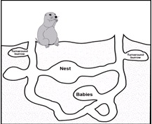
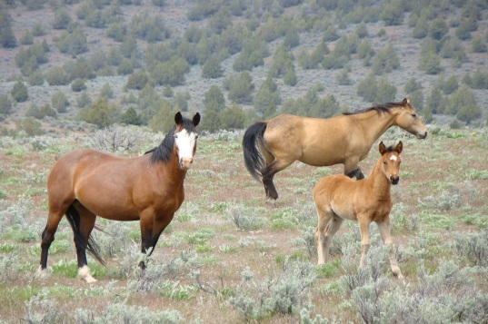
H
Prompt:

Wild Horses

Student first name: Student last name:

Teacher name: Class period:

Grade level:
8th 9th 10th

PROMPT FOR WRITING

H. Wild Horses

Wild horses have become a subject of debate. Wild horses are protected by law, and yet the number of horses has increased so much that they cannot get enough to eat on public land. What do you think the Bureau of Land Management should do about the challenge of managing wild horses? Why?

Write an argument. Use ideas and evidence from the reading packet to support your argument. Use what you have learned about citing and quoting sources in your writing

The audience for your argument is the Director of the Bureau of Land Management.

DIRECTIONS
- Take five minutes to review your reading packet, notes and planning page from Day 1.
- Use the space on the next page if you want to plan and organize before you write.
- Begin writing your argument on page 3. Use as much space as you need to complete your argument.

PLANNING YOUR WRITING (optional)

START WRITING HERE

IF YOU NEED ADDITIONAL SPACE TO WRITE, get lined paper from your class and staple to this packet when you’re done writing.

