College-Ready Writers Program

Writing Task

Day 1 Reading Packet H

Wild Horses

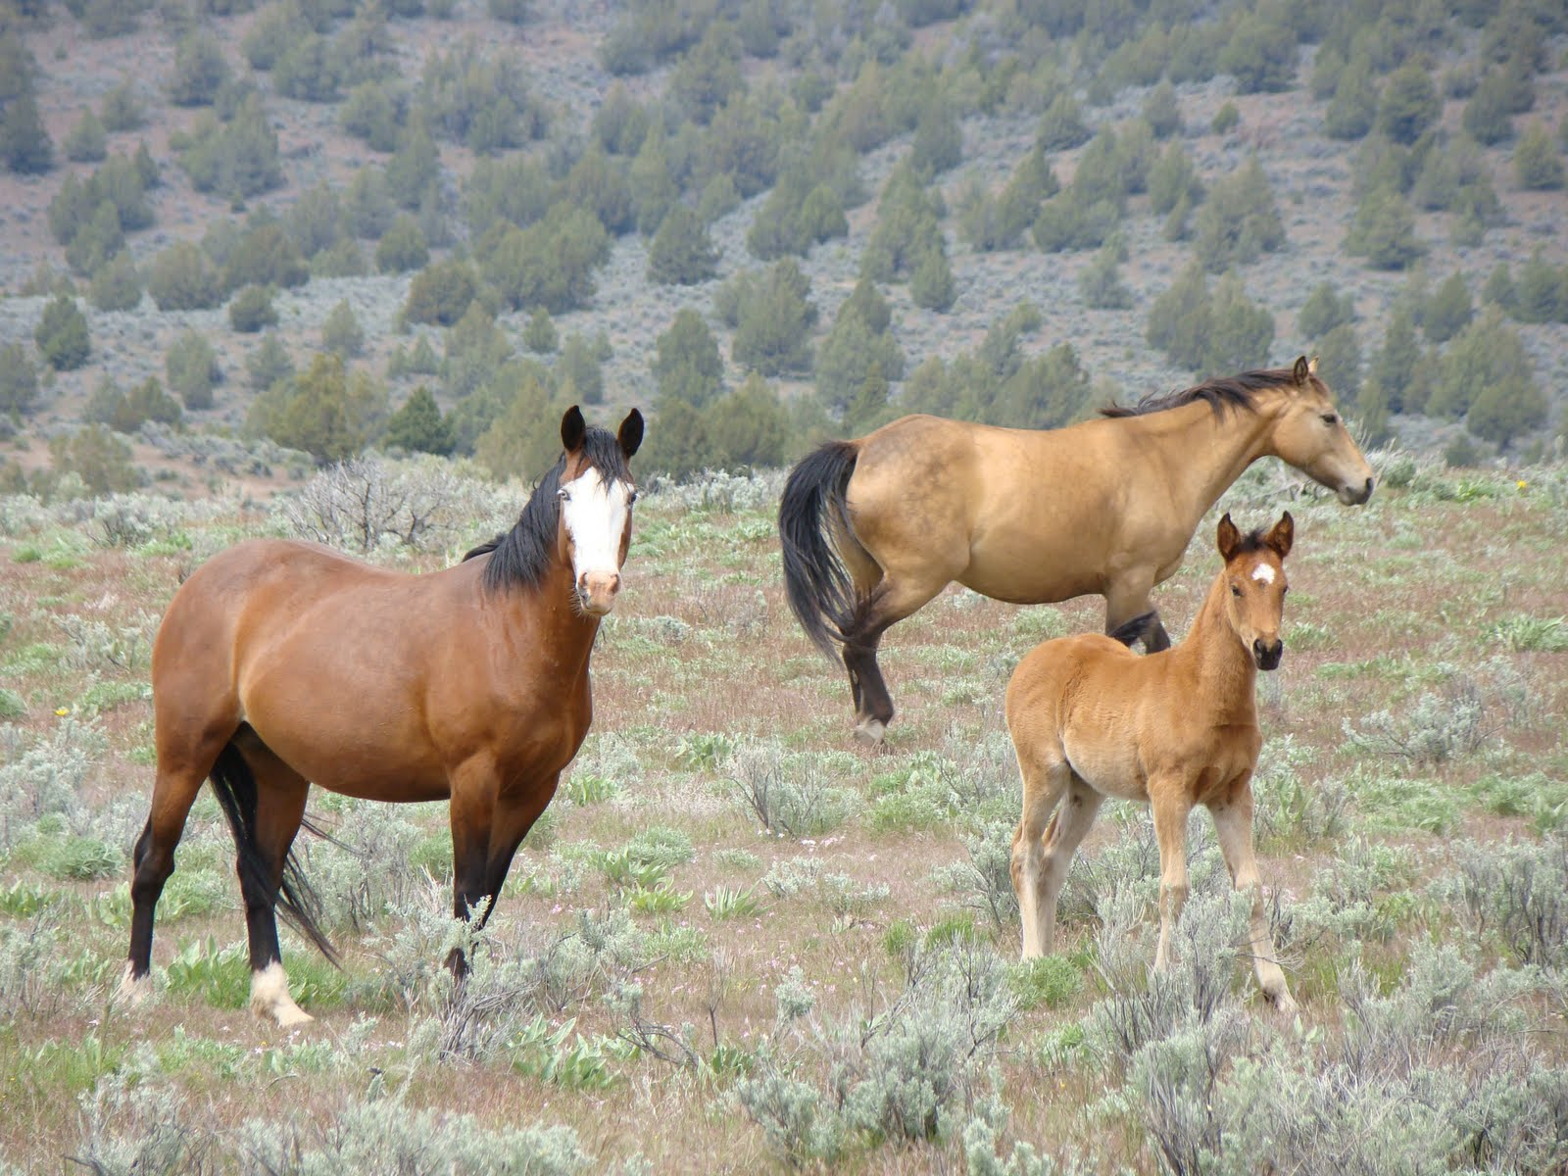
Northern wild horses Source: US Fish and Wildlife Service

Student first name: Student last name:

Teacher name: Class period:

Grade level:
8th 9th 10th

PROMPT FOR WRITING

H. Wild Horses

Wild horses have become a subject of debate. Wild horses are protected by law, and yet the number of horses has increased so much that they cannot get enough to eat on public land. What do you think the Bureau of Land Management should do about the challenge of managing wild horses? Why?

Write an argument. Use ideas and evidence from the reading packet to support your argument. Use what you have learned about citing and quoting sources in your writing

The audience for your argument is the Director of the Bureau of Land Management.

DIRECTIONS

- This packet is part of a two-day writing task.
- Today you will analyze the readings to learn about different opinions on this topic. On Day 2, you will write an argument that supports your opinion in response to the prompt above.
- Use the space provided in the margins to take notes on the readings.
- On pp. 14-15, you will find definitions for vocabulary words. These words are italicized in the text.
- Use the space on p. 16 to plan your argument for Day 2.

Use margin to take notes

Reading 1
Introduction

Meeting of National Wild Horse and Burro Advisory Board
The National Wild Horse and Burro Advisory Board will meet for two days in Sacramento, California, to discuss the management and protection of wild horses and burros on Western public rangelands. The Advisory Board provides advice to the U. S. Bureau of Land Management (BLM) on how to manage the increasing numbers of wild horses.
The 1971 Wild Free-Roaming Horses and Burros Act requires that the government manage the herds of wild horses so that the horses are healthy and so that the size of the herds is in keeping with the land’s capacity to support them. At this time, about 40,600 wild horses roam lands in 10 Western states.
The BLM is asking veterinarians, scientists, universities, and the public for advice on how to best keep the numbers of horses from growing too rapidly—because the lands cannot support larger herds. The deadline for submitting a written plan for wild horses is July 1, 2015.

Source: U. S. National Wild Horse and Burro Advisory Board. Bureau of Land Management. March 22, 2014. Posted by KCSG Television

Use margin to take notes
Reading 2

Debate Grows Over Roundup of Wild Horses in Nevada

By Randal C. Archibold
December 31, 2009

The federal Bureau of Land Management this week began its “gather” of about 2,500 wild horses in . . . Nevada. Balancing natural resources is the goal.
With helicopters swooping low and slow, wranglers this week began rounding up wild horses on a vast Nevada range, feeding an intense debate over whether removing the animals helps or hurts the preservation of an enduring symbol of the West. . . .
There are too many of the animals in that area, upsetting the balance of natural resources for flora and fauna, including grazing land for cattle, federal officials said. About 140 horses had been removed as of Thursday. After two months of rounding them up and eventually trucking most to pastures in the Midwest, government officials expect 600 to 800 horses will remain.
“The fact is right now we have three to five times the population of wild horses that the range can sustain,” said Bob Abbey, director of the federal Bureau of Land Management….
Horse advocates unsuccessfully sued to block this roundup. . . . Suzanne Roy, of In Defense of Animals, . . . says the horses should be allowed to stay put. “Wild horses have tightly knit bands,” Ms. Roy said. “This shatters the social structure; foals are separated from their mothers; the horses are put in a very unnatural situation. The whole thing is just a major trauma and terror for these really beautiful horses that have lived peacefully on these lands for hundreds of years.”
But the land management bureau said the “gather,” as it calls it, would ultimately save the lives of horses.
Unlike other animals, wild horses cannot legally be hunted or slaughtered, and they have no natural predator. When the area gets overpopulated, food becomes scarce and the horses suffer, said Mr. Abbey, the agency director, who expressed exasperation with some animal rights advocates. “If it were up to them, we would be allowing wild horses to starve to death, which is no way to honor an American icon,” he said in a telephone interview.
Most of the older animals are moved to distant pastures that provide lots of room and abundant food. The younger horses are put up for adoption. . . .
Use margin to take notes
A goal of the roundup . . . was providing access to grazing land for cattle. Some ranchers have pulled cattle from pockets of the range because there has not been enough vegetation, partly because of the overpopulation of horses but also because of a lingering drought.
Bureau officials said the roundups include safeguards, like a check of the horses by veterinarians. Since Monday, one horse caught in the roundup had to be euthanized because, Mr. Abbey said, it would not have survived the winter because of its advanced age. . . .
The government already keeps 34,000 wild horses and burros captive, mainly in Oklahoma and Kansas. Another 37,000, half in Nevada, roam on bureau territory in 10 states.
Source: New York Times. December 31, 2009. A version of this article appeared in print on January 1, 2010, on page A17 of the New York edition.
About the author: Randal C. Archibold is the New York Times bureau chief for Mexico, Central America and the Caribbean. Before beginning his assignment there, he covered a large swath of the southwestern United States.

Use margin to take notes
Reading 3

Living with Wild Horses
By Steve Louis

Wild horses roaming outside of their herd management areas have caused vehicle accidents, personal injury, and property
damage. Additionally, wild horses can spread disease to domestic horses. In the three-year period from 1997 to 2000, 93 vehicular accidents were horse related and resulted in 25 personal injuries in six western Nevada counties.

Damage to landscape, fencing, irrigation equipment and other property, has resulted from wild horses wandering into residential neighborhoods.

The Law
In 1971 The U.S. Congress passed the Wild Horse and Burro Act. This created laws which call for; wild horses to be managed so ecosystems can thrive. . . . In addition to federal law, Nevada law states it is illegal to feed or provide water to wild horses. This practice lures them away from their herd management area and onto private property. It desensitizes horses to people and the urban landscape. Horses found outside their management area are subject to capture by the land management agency.

Feeding is not only illegal it can cause serious health problems. Diet change can cause stomach disorders and possibly death in any horse, wild or domestic. Moldy, weedy hay and even good hay can cause serious health problems.

Keep Them Off Private Property!
Neighborhood residents can use some of the following ideas to help keep wild horses off private property. In areas designated “Open Range”, private property owners are required by law to fence out livestock and wild horses…. In some instances the land management agency may be willing to work with a volunteer group of committed citizens. This group of horsemen would be responsible for moving wild horses back
into their management area. Members of the posse would be trained by agency experts to insure they worked within the law. . . .

Source: Louis, Steve. “Living with Wild Horses. ”University of Nevada, Reno, Cooperative Extension Service. Fact sheet-01-36.Web. 28 March 2014.

About the author: Steve Louis is an extension educator at the University of Nevada Cooperative Extension Service.
Use margin to take notes
Reading 4

Wild Horses and the Ecosystem
By American Wild Horse Preservation Campaign

The Wild Free-Roaming Horse and Burro Act recognizes the wild horse as an "integral component of the natural system." It stipulates that horses can only be removed from public lands if it is proven that they are overpopulating or are causing habitat destruction. … The Bureau of Land Management (BLM) has never presented any evidence that horses destroy habitat, nor that their population levels are what it claims they are. . . .In stark contrast with BLM’s assertions, scientific studies have shown that horses actually benefit their environment in numerous ways. . . .

Cows have no upper front teeth, only a thick pad: they graze by wrapping their long tongues around grass and pulling on it. If the ground is wet, they will pull out the grass by the roots, preventing it from growing back. Horses have both upper and lower incisors and graze by "clipping the grass," similar to a lawn mower, allowing the grass to easily grow back.

In addition, the horse’s digestive system does not thoroughly degrade the vegetation it eats. As a result, it tends to “replant” its own forage with the diverse seeds that pass through its system undegraded. This unique digestive system greatly aids in the building up of the absorptive, nutrient-rich humus component of soils. This, in turn, helps the soil absorb and retain water upon which many diverse plants and animals depend. In this way, the wild horse is also of great value in reducing dry inflammable vegetation in fire-prone areas. Their tendency to range widely throughout both steep, hilly terrain and lower, more level areas, while cattle concentrate on lower elevations, also explains why horses have a lesser impact on their environment than livestock: their grazing habits cause horses to nibble and then move to the next bunch of grass. This is why horse range is seldom denuded. . . .

Wild horses should not be used as scapegoats for range degradation that is in fact primarily caused by private livestock: for instance, environmentalists have determined that in Nevada, home of the vast majority of America's remaining wild horses, the herds have little impact on the ecosystem compared with the hundreds of thousands of cattle that also roam the Nevada range. The Western Watersheds Project acknowledges that "the main cause of degradation of public lands in the arid west is livestock use and not wild horses."

Use margin to take notes

Source: ”Wild Horses and the Ecosystem.” American Wild Horse Preservation Campaign. All rights reserved. © 2004-2013. Web. 28 March 2014.

Reproduction authorized solely for educational purposes.

About the author: The American Wild Horse Preservation Campaign (AWHPC) is dedicated to preserving American wild horses and burros in viable free-roaming herds for generations to come, as part of our national heritage.

Use margin to take notes
Reading 5

Report Criticizes U.S. Stewardship of Wild Horses

By Dan Frosch

Published: June 6, 2013

DENVER — A new report catalogs a range of problems with the way the federal government is managing thousands of wild horses and burros. . . . It also said that the bureau’s policy of removing the animals from the range and taking them to holding facilities as a means of population control, an approach that has drawn sharp criticism from wild horse proponents, did not work. . . . “Compelling evidence exists that there are more horses and burros on public rangelands than reported at the national level and that population growth rates are high.”

Wild horses . . . have been at the center of an increasingly bitter dispute over the past several years. The bureau contends that their numbers have become unmanageable. And it says it has little choice but to bring them to enclosed pastures so that other animals can share the land. Horse advocates counter that the horses should be allowed to live freely.
The bureau estimates that about 37,300 wild horses and burros roam on federally managed rangeland in 10 Western states and that nearly 50,000 additional animals are being cared for at short-term corrals and long-term pastures. With essentially no natural predators, herds typically double every four years.
The National Academy of Sciences report found that the bureau had most likely undercounted the horses by 10 to 50 percent. It also said that the bureau’s horse removals might inadvertently allow the animal population to swell by reducing competition for forage.
The report recommended that more fertility control drugs be used as an alternative, a departure from the bureau’s current approach. “It needs to be used in a consistent, widespread manner, which has not been done today,” said Dr. Guy Palmer, a veterinarian at Washington State University and the chairman of the committee that conducted the study. . . .
“The report is a powerful validation of what wild horse advocates have been saying for years,” said Suzanne Roy, director of the American Wild Horse Preservation Campaign. “The report delivers a strong case for an immediate halt to the
Use margin to take notes
roundup and removal of wild horses from the range, an increase in wild horse and burro population levels and implementation of in-the-wild management using available fertility control options.”
BLM spokesman, Tom Gorey, said the bureau needed and wanted to do a better job managing the animals, but was well aware the program was in a “crisis” because it was running out of holding space. Mr. Gorey also pointed out that because fertility control treatments lasted only one to two years, some horse removals would have to continue.
Leaving the population control to nature, he said, “would subject horses and burros to mass starvation and dehydration,” he said. “We don’t think that laissez-faire style is something the American public or Congress would support.”. . .

Source: Frosch, Dan. “Report Critisizes U. S. Stewardship of Wild Horses.” New York Times. New York Times, 6 June 2013. Web. 26 March 2014.

A version of this article appeared in print on June 7, 2013, on page A13 of the New York edition with the headline: Report Criticizes Federal Stewardship of Wild Horses.

About the author: Dan Frosch covers the Southwest for the New York Times.

Use margin to take notes
Reading 6

Should We Protect Wild Horses?
By Chuck Klosterman, March 21, 2014

Question: In the United States, it’s illegal to kill a wild horse on public lands. Yet wild horses can have destructive grazing behavior, and indigenous grazers and browsers (deer, for example) have to compete with them for land. . . Is it unethical to protect wild horses? T.G., NEW YORK
Response: . . .Your argument is that wild horses hurt the environment; I’d argue that wild horses have become part of the environment itself. Horses alter the ecological landscape, but we’d be altering the landscape by eliminating the horses.
If your point is that there’s a degree of hypocrisy in the human relationship with horses, I [agree]. There are certain animals humans tend to care about more than others, and it can seem arbitrary. If your thoughts on animal rights exist at one of the philosophical poles — if you believe no animal should ever be killed, or if you believe any animal can be killed for any reason — this question is easy. But most people are somewhere in the middle, holding views that don’t always make rational sense. For example, I find the extermination of invasive pythons in Florida less unsettling than the extermination of invasive Mustangs in Nevada. This is my emotional reaction. But ethics forces people to consider things that might contradict their feelings.
The Bureau of Land Management estimates there are about 33,780 wild horses on public U.S. rangeland. The optimal population would be smaller by several thousand. Some may argue that thinning the herd increases the quality of life for the species as whole, which is true — assuming you’re not one of the horses to be eliminated.
I would ultimately say this: It’s unethical to protect wild horses (which are currently not categorized as endangered) if our only reasoning is that we happen to like horses and believe they deserve preferential treatment. Our policy and criteria for horse populations should be the same as our policy for coyotes or any other mammal. But none of these species should be radically culled unless they pose a direct threat to human well-being, which does not appear to be the case. Now, if that sounds as if I’m “privileging” human life over nonhuman life, it’s because I am. I don’t think humans and nonhumans are equal. But that doesn’t mean we can treat animals as bloodless statistical populations that we control at our convenience.
Use margin to take notes

Source: Klosterman, Chuck. “Should We Protect Wild Horses?” New York Times. New York Times, 21 March 2014. Web. 28 March 2014.

About the author: Chuck Klosterman is full-time ethicist for the New York Times who, as a writer, confronts all manner of thorny questions and who isn’t afraid of expressing his opinions about how things are and How They Should Be.

Reading 7

Source: FY 2013 Wild Horse and Burro Herd Populations and Appropriate Management Levels by State. U. S. Department of the Interior, Bureau of Land Management. 2013

Take notes below:
What do you notice about the number of horses and burros that the land can support compared to the actual number them in the wild?

Use margin to take notes
Vocabulary

arbitrary: not planned or chosen for a particular reason or evidence, done without concern for what is right

burro: a small donkey

U. S. Bureau of Land Management (BLM): The government agency responsible for 8.7 million acres of public lands in 10 Western States.

degrade: in digestion, to decompose or break down food. (Seeds eaten by horses are undegraded (not broken down) as they pass through the horse’s digestive system.)

denuded: stripped of grass

desensitize: to extinguish an emotional response such as fear

enduring symbol of the West: in this case, horses are symbolic of the history of the West

ethicist: a person concerned with right and wrong

euthanized: to kill an animal painlessly to relieve suffering

fertility control: methods of inhibiting population growth in animals through hormone implants, surgical procedures, chemicals, or vaccines. In the U.S., reproductive inhibitors for wildlife must undergo extensive federal review before being approved. Contraceptives for wild and feral animals are regulated by the Environmental Protection Agency.
Source: The Wildlife Society, Bethesda, MD. tws@wildlife.org

forage: bulky food such as grass or hay

hypocrisy: pretending to have moral standards or beliefs that one’s actions do not illustrate

indigenous: native; occurring naturally in a particular place

laissez-faire: French for “leave it be” or “let do;” an environment of little to no regulation or interference by government

Mustang: free-roaming (wild) horses of the west

optimal: best or most favorable

preferential: partiality; treating one person or species better than others for no logical reason
Use margin to take notes

wild horse proponents: people concerned about the well-being of wild horses

wranglers: a cowboy who controls horses

Planning Your Argument
Wild horses have become a subject of debate. Wild horses are protected by law, and yet the number of horses has increased so much that they cannot get enough to eat on public land. What do you think the Bureau of Land Management should do about the challenge of managing wild horses? Why?

Use this space to:
- Write your claim.
- Select and organize evidence from the readings that you will use to write your argument on Day 2.

