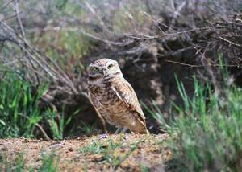
WHY ARE BURROWING OWLS ON THE ENDANGERED SPECIES LIST?
by Vivian Gomez, Demand Media (Adapted for classroom use, 6.4)
Jupiterimages/Photos.com/Getty Images

Burrowing owls are endangered in Canada. They are threatened in Mexico. They are also endangered, threatened or of special concern in nine U.S. states.

Unlike other owls, burrowing owls are active during the day and at night. They make their nests in underground burrows. They use holes dug by prairie dogs, badgers, or ground squirrels. They prefer to live in open grasslands.

Several factors are responsible for their rapidly declining numbers.

Human Encroachment
Human encroachment plays a big role in the declining numbers of burrowing owls. As grasslands are cleared to make way for roads, houses and farms, burrowing owls lose their natural habitat. Areas that had few humans are suddenly packed with them. This puts the owls near busy roads and highways where they get hit.

Pesticides
Burrowing owls who now share their habitat with farmers suffer because of the pesticides farmers use. Pests include grasshoppers, which burrowing owls consume. If they eat too many grasshoppers exposed to pesticides, the owls are poisoned, too. Farmers kill pests like prairie dogs, ground squirrels and badgers. As these rodents are killed, the owls are left without homes, too, because they are unable to dig their own burrows.

The Circle of Life
Burrowing owls also face natural predators. Hawks, horned owls and foxes all feed on them. Domestic pets also endanger their eggs and young. The owls sometimes are killed and eaten by badgers. The badgers mistake them for ground squirrels, in whose burrows they also reside.

Climate Change
Climate change has also decreased the number of burrowing owls. Heavy rainstorms flood burrows in Canada. Droughts lead to fires in the western US. Worse, grassland habitats are drying out due to warmer temperatures. This makes grasslands uninhabitable for burrowing owls and other birds.

