What Can We Expect for Future Landfill Space?
Adapted from an article by Barbara Hudson, Chartwell Information Services (8.8)

James Thompson, Jr. is president of Chartwell Information, Inc. Chartwell was one of the first U.S. companies to publish data about waste disposal needs.
In the 1980s, many groups said we were running out of places to put our trash. The scare led companies to build more landfills, however. In Thompson's opinion, there was never a shortage.
In 1991, Chartwell discovered the U.S. had enough working landfills for over 18 years. Thompson says this is more than enough to handle our needs.
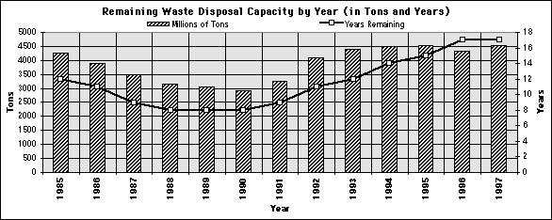
According to Chartwell, the U.S. has landfill capacity for the next 18 years if no new facilities or expansions are built (see graph).

This article is adapted from American Sweeper magazine, Volume 6 Number 2.

© 2005 - 2012 World Sweeper
All rights reserved.
Retrieved 7-26-14 from http://www.worldsweeper.com/Disposal/v6n2landfills.html.

