Retrieved 4-26-15 from http://wastefreelunches.org/what-is-a-waste-free-lunch-program.html#waste-free-lunch-cost
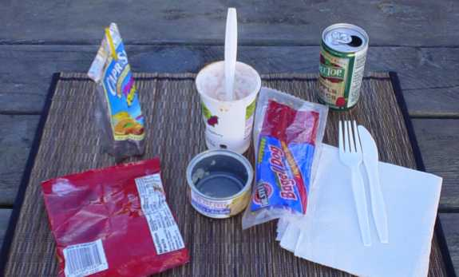
If you're interested in learning more about waste-free lunches, you've come to the right place. Our aim is to provide you with all the information you need to participate in (or to start!) a waste-free lunch program at your school or place of employment. If you have information to share, we'd love to hear from you!

What's the Problem?
As Americans we have come to depend on the many convenience products that are available to us, and nowhere is this more evident than in the school lunch room. Most parents pack lunch items in single-use plastic bags, aluminum foil, or wax paper, or they purchase single-serving items that come in their own disposable package. Admittedly, these products are extremely convenient, but what is the environmental cost to a country that relies so heavily on them? Landfills are full and overflowing. Incinerators pump contaminants into the air. Communities are battling over who will accept the nation's trash. We all enjoy these conveniences, but few of us are willing to allow new landfills and incinerators to be built in our own backyards.
Much of the trash we generate comes from the packaging on the food we buy, and lunch foods are no exception. In fact, it has been estimated that on average a school-age child using a disposable lunch generates 67 pounds of waste per school year. That equates to 18,760 pounds of lunch waste for just one average-size elementary school.

What can we do to reduce lunch waste?
Start local! Start a waste-free lunch program at your school. Many schools across the country have begun to do so, and they're truly making a difference!

What is a waste-free lunch program?
A waste-free lunch program begins with a statement. A school community decides that it is going to make waste reduction on campus a priority, and one of the best places to start is with lunch and snack waste. Whether the majority of students brings lunch from home or buys it at school, there's almost always room for improvement. A waste-free lunch program is a process of educating students, parents, and school staff about where our trash ends up and how we, as individuals, can reduce the amount of trash we generate. Waste-free lunch programs favor the use of reusable food containers, drink containers, utensils, and napkins. They discourage the use of disposable packaging, such as prepackaged foods, plastic bags, juice boxes and pouches, paper napkins, and disposable utensils.

What does a waste-free lunch look like?
A Typical American Lunch  (DISPOSABLE)  - sandwiches sealed in plastic bags  - fruits and vegetables in plastic bags  - prepackaged chips, cookies, fruit bars, granola bars, cheeses, and fruit leathers  - prepackaged yogurts, applesauces, and puddings  - crackers, pretzels, chips, and other snack foods sealed in plastic bags  - disposable juice boxes, juice pouchs, soda cans, water bottles, and milk cartons  - plastic forks and spoons  - paper napkins  - reusable lunchboxes and disposable paper and plastic bags | A Waste-Free Lunch  (REUSABLE)  - sandwiches and other main dishes, fresh fruit, fresh vegetables, and treats in a reusable lunch container  - cloth napkins  - stainless-steel forks and spoons  - reusable drink containers  - reusable lunchboxes  *With this type of lunch, lunch food items can be bought in larger quantities. The packaging can be left at home for reuse or recycling. Waste-free lunches are not only a wise environmental choice, but they are less expensive as well.

What does it cost to pack a waste-free lunch?

A Disposable Lunch  1 egg salad sandwich $1.25  1 yogurt .85  1 granola bar .45  1 apple .30  1 package of carrots and dip .65  3 plastic bags .12  1 juice pouch .35  1 plastic spoon .04  1 paper napkin .01  TOTAL $4.02 | A Waste-free Lunch  1 egg salad sandwich $1.25  1 serving of yogurt .50  1 serving of granola .35  1 apple .30  1 serving of carrots and dip .25  water 0  cloth napkin 0  stainless steel spoon 0  packaging 0  TOTAL $2.65
The Bottom Line
Disposable Lunch | Waste-Free Lunch
$4.02 / day | $2.65 / day
$20.10 / week | $13.25 / week
$723.60 / school year | $477.00 / school year
723.60 - 477.00 = $246.60 savings per school year per person
© copyright 2011 - wastefreelunches.org, All rights reserved.
REPRINT PERMISSION: Feel free to reprint portions of this Web site with the following acknowledgment clearly visible: "Content courtesy of www.wastefreelunches.org."

