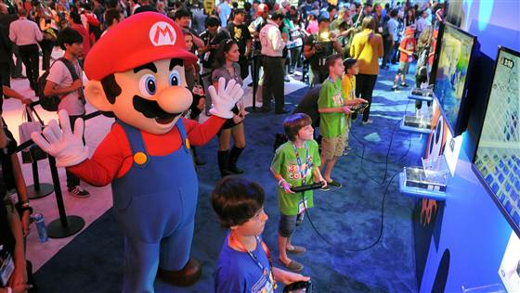
Video games are good for you (a little bit)
Linda Carroll, TODAY contributor
Aug. 4, 2014 at 12:03 AM ET (9.4)
- Facebook
Children try out a new video game at Nintendo's booth during E3 on June 11, 2014, in Los Angeles. Handout / Getty Images

Video games might actually be good for kids — but only if they play for an hour or less per day, a new study suggests.
Compared to children who didn’t play at all, those who gamed for a few hours a week were better adjusted, had fewer conduct problems and were more likely to care about others, according to the study published Monday in Pediatrics.
When kids spent one to three hours a day gaming, those positive effects seemed to disappear. And when they gamed more than that, kids were more likely to have problems with hyperactivity and inattention, to show a lack of empathy and to report less satisfaction with life.
“There’s a wide range of reasons to think that some level of exposure to electronic games might be advantageous to young people,” said the author of the study, Andrew Przybylski, an experimental psychologist and a research fellow at the Oxford Internet Institute at Oxford University.
Other research has shown that playing video games can “produce feelings of happiness,” Przybylski said. Further, games can give kids a feeling of connectedness if they are playing with other children, he said.
That certainly rings true to Laurie Wing, whose 13-year-old son, Christopher, often hops online to play games with friends after dinner.
“They play 'Minecraft' and build cities,” the 48-year-old mom from Howell, New Jersey, said. “It’s so educational. He calls me in to see what they’re building and to explain how everything works. I often can hear him laughing when he’s playing.”
The only downside, Wing said, is that kids want to play 'til all hours of the night. “My son gets texts at midnight from friends on the weekends,” she said. “He tells me that some play till 4 a.m. I tell him to forget about it.”
Nichelle Pace, 42, whose 11-year-old son, Jonathan, plays a little more than an hour a day, is happy to see her son socializing with a wide range of new friends.
Courtesy Nichelle Pace
Nichelle Pace with sons Julian, 22, and Jonathan, 11. Pace says her 11-year-old son plays video games for about an hour a day.

“He’s got online friends from Canada, and sometimes in the summer he connects with kids in the U.K.,” said the Sicklerville, New Jersey, mother of two. “I do find it appealing that they seem to have their own little subculture that crosses ethnic and cultural lines. In that age group they all seem to have the same kind of lingo.”
For the new study, Przybylski and his colleagues surveyed nearly 5,000 girls and boys from England, Northern Ireland, Scotland and Wales. The children, whose ages ranged from 10 to 15, were asked about the amount of time spent gaming. They were also asked to fill out a series of psychological questionnaires.
Przybylski hopes that the study results will be reassuring to parents who worry that any video game play might be harmful. And, ultimately, he cautions that the effects seen in the study, both positive and negative, are small.
The new findings do suggest some video game play might be beneficial, said Patrick Tolan, a professor of education and psychiatry and director of the Youth-Nex Center for Positive Youth Development at the University of Virginia. “That said, kids playing video games may not be as physically active as others and may not be as engaged as they would be when they talk to someone in person,” Tolan added.
Parents need to keep a close eye on what their children are playing, Tolan said. And it’s not enough to just oversee which games your child plays, you should also play the games with them to see what’s really involved, he added.
One shortcoming of the new study is that it doesn’t prove that the games are having an effect, said Dr. Dimitri Christakis, George Adkins Professor at the University of Washington and director of the university’s Center for Child Health, Behavior & Development and co-author of the American Academy of Pediatrics’ guidelines on kids and screen time.
“There could be differences between the children and problems that predate their involvement with video games,” Christakis said. “Also we don’t know what games these children are playing.
“And that’s one of the biggest limitations of studies looking at any kind of screen time, whether it’s television, video games or phone apps. We can’t simply operate in a world anymore where we say a screen is a screen is a screen. Content is what drives the effects on children — and for that matter, adults.”
Parents like Wing are already paying a lot of attention to the games their children are playing.
“There are some we have to refuse,” she said. “We are waiting with him online at midnight when a new game comes out. You have to be careful which ones you let your child have. I’ve seen some that include nudity and cursing. When I see that, I say, ‘No way.’”
While the new study “suggests there are games that are at worst harmless and at best might even be beneficial, we can’t know without more research,” Christakis said.
“We know too little about the digital world into which our children have been born. We need to invest more money into research. Right now we just have a large uncontrolled experiment on children.”
Linda Carroll is a regular contributor to NBCNews.com and TODAY.com. She is co-author of "The Concussion Crisis: Anatomy of a Silent epidemic” and the recently released “Duel for the Crown: Affirmed, Alydar, and Racing’s Greatest Rivalry.”

