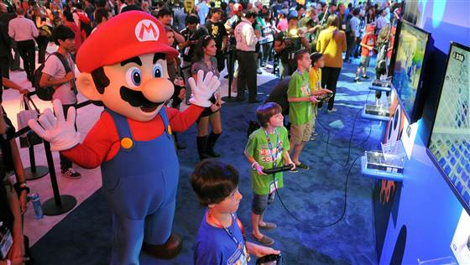
Video games are good for you (a little bit)
Linda Carroll, TODAY contributor
Aug. 4, 2014 at 12:03 AM ET (7.2)
- Facebook
Children try out a new video game at Nintendo's booth during E3 on June 11, 2014, in Los Angeles. Handout / Getty Images

Video games might actually be good for kids, a new study suggests. But only if they play for an hour or less per day.
Compared to children who didn’t play at all, those who gamed a few hours a week were better adjusted. They had fewer conduct problems. They were also more likely to care about others, according to the study published in Pediatrics (August 2014).
When kids spent 1 to 3 hours a day gaming, no positive effects were noticed. And when they gamed more than that, kids were more likely to have trouble with hyperactivity and inattention. They also showed lack of empathy. Heavy gamers rated themselves as less satisfied with life.
“There’s a wide range of reasons to think that some level of exposure to electronic games might be advantageous to young people,” said the author of the study, Andrew Przybylski. He is an experimental psychologist and a research fellow at the Oxford University Internet Institute.
Other research shows that gaming can “produce feelings of happiness,” Przybylski said. Further, games can give kids a feeling of connectedness if they are playing with others, he said.
That rings true to Laurie Wing. Her 13-year-old son, Christopher, often hops online to play games with friends after dinner. They live in Howell, New Jersey.
“They play 'Minecraft' and build cities,” said Mrs. Wing. “It’s so educational. He calls me in to see what they’re building and to explain how everything works. I often can hear him laughing when he’s playing.”
The only downside, Wing said, is that kids want to play 'til all hours of the night. “My son gets texts at midnight from friends on the weekends,” she said. “He tells me that some play till 4 a.m. I tell him to forget about it.”
Nichelle Pace, 42, whose 11-year-old son, Jonathan, plays a little more than an hour a day, is happy to see her son socializing with a wide range of new friends.
Courtesy Nichelle Pace
Nichelle Pace with sons Julian, 22, and Jonathan, 11. Pace says her 11-year-old son plays video games for about an hour a day.

The Paces live in the Sicklerville, New Jersey. Jonathan has online friends from Canada. “Sometimes in the summer he connects with kids in the U.K.,” said Mrs. Pace. “I do find it appealing that they seem to have their own little subculture that crosses ethnic and cultural lines. In that age group they all seem to have the same kind of lingo.”
For the new study, Przybylski and his colleagues surveyed nearly 5,000 girls and boys in England, Northern Ireland, Scotland and Wales. Kids of ages 10 to 15 were asked how much time they spend gaming. They were also asked to fill out a series of surveys.
Przybylski hopes the results will reassure parents who worry that any video game play might be harmful. But he warns that the effects found in the study, both good and bad, are small.
The new findings suggest some video game play might be beneficial, said Patrick Tolan. Tolan is a professor of education and psychiatry at the University of Virginia. But “kids playing video games may not be as physically active as others. They may not be as engaged as they would be when they talk to someone in person,” Tolan added.
Parents need to keep a close eye on what their kids are playing, Tolan said. It’s not enough to just oversee which games they play. Parents should also play the games with them to see what’s really involved, he says.
One problem with the new study is that it doesn’t prove that the games cause the differences, said Dr. Dimitri Christakis. He is a professor at the University of Washington. He is also the co-author of the American Academy of Pediatrics’ guidelines on kids and screen time.
“There could be differences between the children and problems that predate their involvement with video games,” Christakis said. “Also we don’t know what games these children are playing.
“And that’s one of the biggest limitations of studies looking at any kind of screen time, whether it’s television, video games or phone apps. We can’t simply operate in a world anymore where we say a screen is a screen is a screen. Content is what drives the effects on children — and for that matter, adults.”
Parents like Wing are already paying a lot of attention to the games their children are playing.
“There are some we have to refuse,” she said. “You have to be careful. I’ve seen some that include nudity and cursing. When I see that, I say, ‘No way.’”
While the new study “suggests there are games that are at worst harmless and at best might even be beneficial, we can’t know without more research,” Christakis said.
“We know too little about the digital world into which our children have been born. We need to invest more money into research.”
---------------------------
Linda Carroll is a regular contributor to NBCNews.com and TODAY.com. She is co-author of "The Concussion Crisis: Anatomy of a Silent epidemic” and the recently released “Duel for the Crown: Affirmed, Alydar, and Racing’s Greatest Rivalry.”

