**Teacher Formative Assessment Tool:**

**Using Source Material**

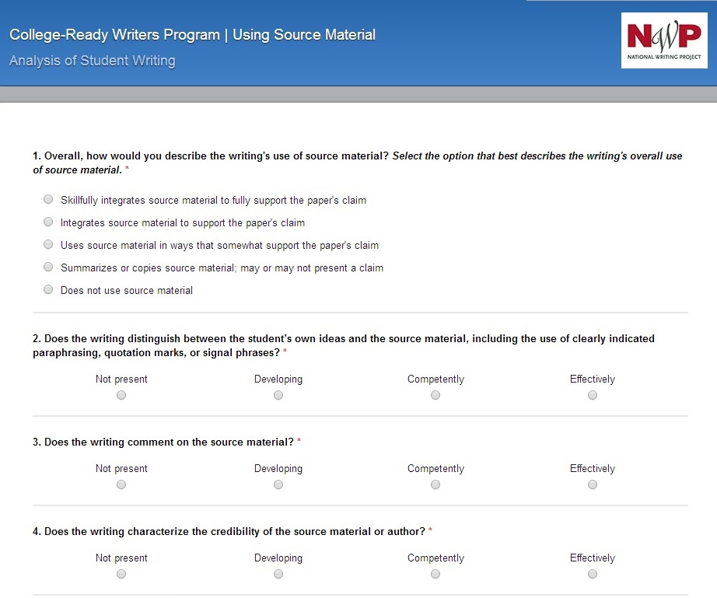**Using Source Material**

**1. Does the writing present a claim?**

* + The writing presents a claim that is compelling, debatable and defensible.
  + The writing presents a general claim that is debatable and defensible.
  + The writing presents a summary statement about source material, but that statement is not debatable.
  + The writing does not present a claim.

**2. Does the writing distinguish between the student’s own ideas and the source material, including the use of clearly indicated paraphrasing, quotation marks, or signal phrases?**

* + Not present
  + Developing
  + Competently
  + Effectively

**3. Does the writing select and use evidence from sources to support the claim?**

* + Not present
  + Developing
  + Competently
  + Effectively

**4. Does the writing comment on source material in ways that connect the source material to the claim?**

* Not present
* Developing
* Competently
* Effectively

**5. Does the writing characterize the credibility of the source material or author?**

* Not present
* Developing
* Competently
* Effectively

**6. Overall, how would you describe the writing’s use of source material? *Select the option that best describes the writing’s overall use of source material.***

* Skillfully integrates source material to fully support the paper’s claim.
* Uses source material to support the paper's claim.
* Includes source material to somewhat support the paper’s claim.
* Summarizes source material, may or may not present a claim.
* Does not use source material.
* Primarily or exclusively copies source material.