Top Ten Mentor Texts for Argument Writing
(Grades K-3)
To teach argument writing, you need a variety of mentor texts that demonstrate the art of persuasion, opinion AND argument. We’ve built a list of books for grades K-3 that do just that. Of course, non-book texts like movie reviews, book reviews and student writing can be great mentor texts for argument writing too!
The Day the Crayons Quit (Grades P-2, Lexile AD730)
When Duncan arrives at school one morning he finds a stack of letters, one from each of his crayons, complaining about how he uses them.
Click, Clack, Moo: Cows that Type (Grades P-3, Level M, Lexile AD160)
When Farmer Brown’s cows find a typewriter in the barn, they start writing up their demands and go on strike when Farmer Brown refuses to give them what they want.
Not Norman (Grades P-3, Level L, Lexile AD460)
As a boy attempts to convince someone else to take his disappointing pet because it can’t chase string, play catch or sleep on his bed, he learns to love Norman the goldfish himself.
Pick a Picture, Write an Opinion! (Grades P-2, Lexile AD680)
Need to write an opinion piece but not sure where to start? Just pick a picture! This title introduces opinion writing to children using photographs as idea prompts.
Can We Save the Tiger? (Grades 1-5, Level S, Lexile 970)
This text highlights the ways human behavior can either threaten or conserve the amazing animals that share our planet.
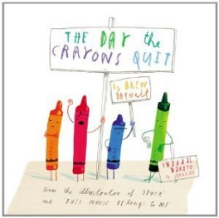 | 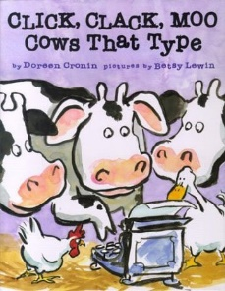 | 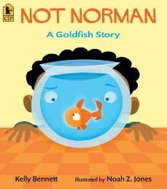
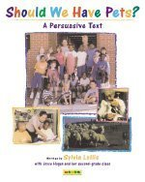 | 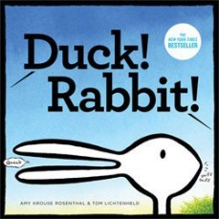 | 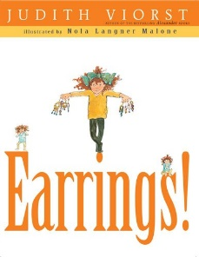 | 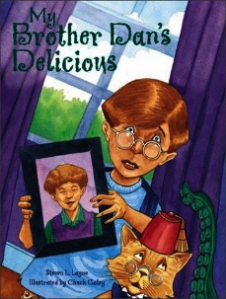 | 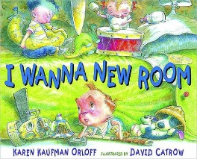
Should We Have Pets? (Grades K-2, Level N, Lexile NC780)
A second-grade class presents arguments for and against pet ownership.
Duck! Rabbit! (Grades P-2, Level I)
Two unseen characters argue about whether the creature they are looking at is a rabbit or a duck.
Earrings! (Grades 1-3, Lexile 470)
A young girl uses various arguments to convince her parents to let her have her ears pierced.
My Brother Dan’s Delicious (Grades K-2, Lexile AD970)
When he finds that he is home alone for the first time, Joey, a bright eight-and-a-half-year-old boy, informs any monsters that might be lurking in the house that his older brother Dan is worth the wait.
I Wanna New Room (Grades P-2, Lexile AD540)
Through a series of brief letters to his parents, Alex presents all the reasons why he should not have to share a room with his younger brother.

http://www.booksourcebanter.com/2015/02/20/top-ten-mentor-texts-argument-writing/

Picture Books that Demonstrate Persuasive Writing
Each of these picture books uniquely shares a style of persuasive writing that can help your student(s) fine tune their own writing.
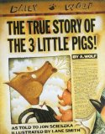 | 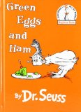 | 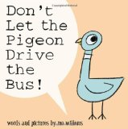
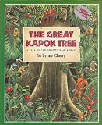 | 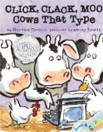 | 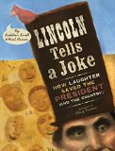
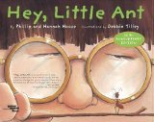 | 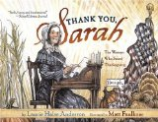 | 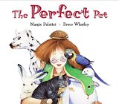
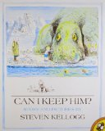 | 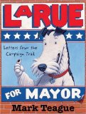 | 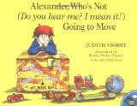
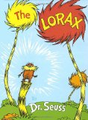 | 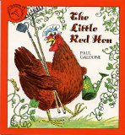
How to Use the Books
Besides simply reading through the books as examples of persuasive writing, I sometimes use bits and pieces of them as mini-lessons to help hone particular skills.
We might talk about what makes a good hook and read the beginning sentences of a few of these books to see how published authors begin their writing.
I might read and reread the thesis from one or more books so we can discuss how important it is to define a clear and concise thesis.
We might analyze one of the books to see how many supporting arguments the author used and how those arguments were presented.
We might talk about the difference(s) in something they have written vs. the master writer. The purpose of this is usually to help my children learn to turn boring, factual writing into more creative writing that someone actually wants to read.
There are so very many lessons you can teach using picture books as examples. One of the easiest ways to start is to simply read a book aloud and ask your student to use the same story structure inserting his own characters, setting and – in the case of persuasive writing – arguments. Having a skeleton of sorts on which to build your own story gives kids a bit more confidence in a new style of writing.

http://ourjourneywestward.com/picture-books-that-demonstrate-persuasive-writing/

