BRAIN & BEHAVIOR

The teenage brain

Adolescence triggers brain — and behavioral — changes that few kids or adults understand
BY AMANDA LEIGH MASCARELLI
2:20PM, OCTOBER 17, 2012
The brain releases dopamine when something makes us feel good — like pulling off an exciting trick. The strength of this “feel good” response in teens helps explain why they sometimes chance real risks.
ISTOCKPHOTO

It’s not easy being a teenager.
The teen years can play out like a choose-your-own-adventure novel, where everyday temptations lead to tough decisions. What if I took that big jump on my bike? What’s the worst thing that could happen if I snuck out after curfew? Should I try smoking?
Teenagers must act on an endless parade of choices. Some choices, including smoking, come with serious consequences. As a result, adolescents often find themselves trapped between their impulsive tendencies (Just try it!) and their newfound ability to make well-informed and logical choices (Wait, maybe that’s not such a good idea!).
So what makes the teenager’s brain so complex? What drives adolescents — more than any other age group — to sometimes make rash or questionable decisions? By peering into the brains of teenagers, scientists who study brain development have begun finding answers.
The evolved teenager
If you have ever thought that the choices teenagers make are all about exploring and pushing limits, you are on to something. Experts believe that this tendency marks a necessary phase in teen development. The process helps prepare teenagers to confront the world on their own. It is something all humans have evolved to experience — yes, teens everywhere go through this exploratory period. Nor is it unique to people: Even laboratory mice experience a similar phase during their development.
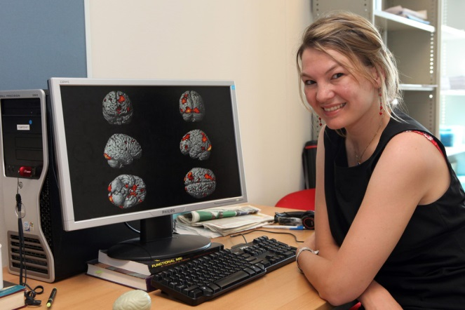
For example, laboratory experiments show that young mice stay close by their mothers for safety. As mice grow, their behavior does too. “When they reach puberty, they’re like, ‘I’m gonna start checking out how this environment looks without my mom,’” explains Beatriz Luna, of the University of Pittsburgh.

Psychologist Eveline Crone studies the teenage brain by observing which parts of it are most active when adolescent volunteers in an MRI scanner play casino-like computer games.
UNIVERSITY OF LEIDEN

As a developmental cognitive neuroscientist, Luna studies those changes that occur in the brain as children develop into adults. She and other researchers are showing how the teen experience can lead to powerful advantages later in life. Take mice again: Young mice that explore most tend to live longest — that is, unless a cat eats them, Luna adds.
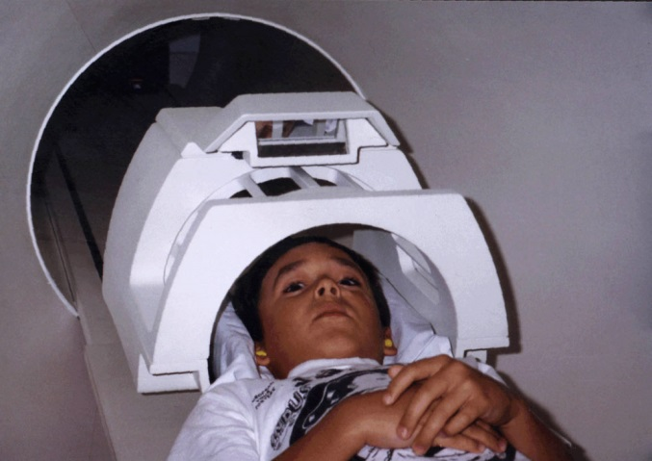
Jackpot!
A young boy prepares to enter a magnetic resonance imaging (MRI) scanner. Earplugs will protect him against the loud noises produced by the rapid pulses of electricity that create the MRI’s powerful magnetic fields.
BEATRIZ LUNA
What really goes on in a teenager’s brain? Of course, neuroscientists can’t actually peer inside the brains of living teenagers. So they do the next best thing; Researchers scan teen brains while their owners are thinking, learning and making critical decisions.
Eveline Crone is a psychologist at Leiden University in the Netherlands who studies how the brain develops. To do so, Crone uses a huge, high-tech instrument called a magnetic resonance imaging (MRI) scanner. The scanner relies on a powerful magnet and radio waves to create detailed images of the brains of Crone’s young volunteers. It is painless and safe. All that Crone’s adolescent subjects have to do is lie back — and play a few games.
As Crone’s volunteers look up, they see a mirror that reflects a computer screen on which they can play casino-like computer games. Press a button and a slot machine appears, allowing teens to gamble — and win. Three bananas in a row? You win a dollar! “Kids love it. They always want to come back,” laughs Crone.
Teens also can play games that require them to make choices, such as whether to pull a trigger, smile at an attractive face or accept a tempting offer. Some choices earn them rewards, such as coins or food.
While her subjects play away, Crone and her coworkers are hard at work observing and measuring which parts of the teens’ brains are most active. The researchers can pinpoint activity by observing how much oxygen various brain regions are using. Very active parts of the brain use a lot of oxygen.
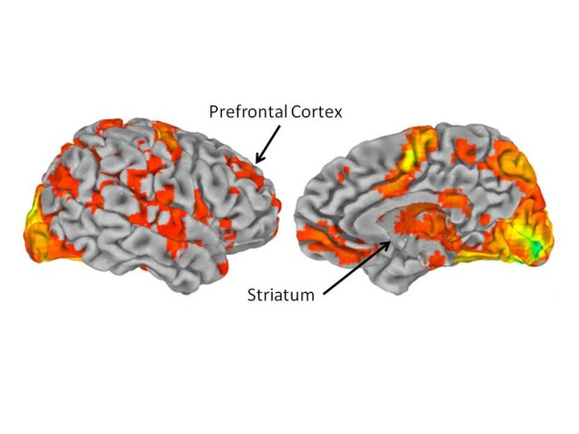
During the risk-taking and rewards-based tests, one region deep inside the brain shows more activity in adolescents than it does in children or adults, Crone says. This region, known as the ventral striatum, is often referred to as the “reward center” of the brain. The region can drive us to repeat behaviors that provide a reward, such as money and treats.
Concludes Crone: This physical difference in adolescent brain activity “shows that adolescence is a unique phase in development.”
These brain scans highlight the prefrontal cortex, just behind the forehead, and the ventral striatum, deeper inside the brain.
BEATRIZ LUNA

Tug-of-war
Adolescents are particularly sensitive and responsive to influence by friends, desires and emotions, researchers say. It’s one of the hallmarks of this stage in life.
A major reason why teenagers often respond to those influences with irrational decisions is the presence of a brain chemical known as dopamine. The brain releases dopamine when something makes us feel good, whether it’s receiving a teacher’s compliment or finding a $20 bill. Dopamine levels in general peak during adolescence. In teenagers, the strength of this “feel good” response helps explain why they often give in to impulsive desires.
B.J. Casey of Cornell University tries to understand these biological patterns in teenagers. In laboratory experiments, this brain scientist and her coworkers have seen increased activity in the ventral striatum whenever someone at any age is confronted by a risky decision or the offer of a reward. However, this brain region seems “to be shouting louder” between the ages of 13 and 17 than at any other time during human development.
Crucially, the ventral striatum also communicates with another brain region, this one located just behind the forehead. Called the prefrontal cortex, it’s the brain’s master planner.
Another way to think of the prefrontal cortex is as the conductor of an orchestra. It gives instructions and enables chatter among other brain regions. It guides how we think and learn step-by-step procedures, such as tying our shoelaces. Even preschoolers rely on the prefrontal cortex to make decisions. Overall, the prefrontal cortex’s ability to boss the brain increases with age.
Casey’s research shows how the adolescent brain is locked in a tug-of-war between the logical pull of the prefrontal cortex and the impulsive pull of the ventral striatum. Although teens can make good decisions, “in the heat of the moment — even when they know better,” the reward system can outmuscle the master planner. That can lead to poor decisions, Casey says.
In fact, teenagers almost cannot help but respond to the promise of a reward, Casey says. “It’s like they’re pulled toward it.” It even happens if the choice appears illogical.
While this would appear to push teenagers toward years of serious risk-taking, it is no mistake of evolution. Casey and other researchers believe the adolescent brain specifically evolved to respond to rewards so teens would leave behind the protection provided by their parents and start exploring their environment — a necessary step toward the independence they will need in adulthood.
Improved chatter
While all of this is going on during adolescence, the prefrontal cortex seems to lag in developing. It turns out this delay serves an important evolutionary function, says Michael Frank of Brown University. Frank studies the brain processes that occur during learning and decision making.
The prefrontal cortex is important because it teaches the rest of the brain the rules about how the world works. So it’s important that the master planner not be too rigid or restrictive during adolescence. Instead, it stays open to learning. Only later on in development can the brain disregard less useful information, Frank says.
Prior to adolescence, the master planner isn’t quite advanced enough to guide allthe other brain regions. That’s because it still doesn’t know the rules of the game. “So that’s why you have parents to act as your prefrontal cortex,” Frank jokes. Then, all too often, he says, “you reach adolescence and you don’t listen to your parents anymore.”
Pruned, not shriveled
During adolescence, two key processes appear to play an important role in the maturing of our brains. One of the processes involves axons, or fibers that connect nerve cells. From infancy, these fibers allow one nerve cell to talk to another. Throughout the teen years, fatty tissue starts to insulate the axons from interfering signals — it is a bit like the plastic that coats electrical cables.
In axons, the insulating tissue allows information to zip back and forth between brain cells much more quickly. It also helps build networks that link the prefrontal cortex with other brain regions, allowing them to work together more efficiently. Eventually, the master planner can send messages throughout the brain with speed and precision.
The second key process involves synapses. A synapse is like a dock between nerve cells. Nerve cells communicate by transmitting chemical and electrical signals. Those signals move through the synapses.
In their first three years of life, children develop seemingly endless connections in their brain circuitry. Then, beginning in adolescence, the brain starts discarding many of these connections. Luna, the developmental cognitive neuroscientist, compares it to an artist who begins with a block of granite and carves away any unneeded stone to create a sculpture. In this case, the brain acts as the sculptor and chops away excess synapses. Scientists refer to this process as synaptic pruning.
By this stage, the brain has learned which synapses are most useful, Luna explains. So the brain strengthens the synapses it really needs and eliminates those that either slow things down or aren’t useful. For example, as people grow older, they become more proficient in their native tongue but find it harder to learn a language they have never spoken before. They may lack some of their earlier language-learning synapses.
Synaptic pruning and other changes that occur in the adolescent brain give teenagers the tools to start making decisions on their own — even if they’re bad decisions, says Luna.
“Now you have a brain that says, ‘I can make my own decisions. I can skateboard down those steps,’” says Luna. “When you’re a kid, you’d check with Mom. But now you have the prefrontal system that gives you the ability to make decisions.”
Combined, all of these processes help explain the sometimes logical — but often impulsive or unpredictable — decisions that the teenage brain can make. So next time you are torn over whether a reward is worth a certain risk, remember the tug-of-war that’s taking place in your brain — and that somewhere in there, you have the tools to make the best decision.
Power Words
adolescence: A transitional stage of physical and psychological development that begins at the onset of puberty, typically between the ages of 11 and 13, and ends with adulthood.
axon: The long, tail-like extension of a neuron that conducts electrical signals away from the cell.
evolve: To change gradually over generations.
magnetic resonance imaging (MRI): An imaging technique used to visualize internal structures of the body.
neuron: An electrically excitable cell that receives, conducts and transmits messages throughout the nervous system.
prefrontal cortex: The front portion of the brain, just behind the forehead, which controls executive functions in the brain.
synapse: The junction between neurons that transmits chemical and electrical signals.
synaptic pruning: The reduction in the number of neurons and synapses that begins in infancy and is mostly complete by early adulthood.
ventral striatum: A region deep inside the brain known as the brain’s reward center.
Further Reading
Eveline Crone explains the developing teenage brain (in Dutch with English subtitles).
S. Ornes. “The ups and downs of a teenage brain.” Science News for Kids. Nov. 9, 2011.
E. Sohn. “Teen brains, under construction.” Science News for Kids. Sept. 19, 2005.
S. Gaidos. “Contemplating thought.” Science News for Kids. Feb. 20, 2009.
Teacher’s questions: Questions you can use in your classroom related to this article.

