The teenage brain

Adolescence triggers brain — and behavioral — changes that few kids or adults understand
The brain releases dopamine when something makes us feel good. The strength of this “feel good” response in teens helps explain why they sometimes take risks.

Adapted from an article BY AMANDA LEIGH MASCARELLI, Science News for students. 2:20PM, OCTOBER 17, 2012
Adapted version, 5.1

It’s not easy being a teen.
Temptation is everywhere. What if I took that big jump on my bike? What’s the worst that could happen? Should I sneak out after curfew? Should I try smoking?
Teens must make choices every day. Some choices, like smoking, have serious consequences. Teens sometimes must fight their impulses. One part of their brain says Just try it! The other part of their brain says Wait! Maybe that’s not such a good idea!
What makes the teen brain so complex? What leads teens to make unwise decisions? This doesn’t happen as much to kids or adults. Why? Scientists are finding answers by looking into the brains of teens.
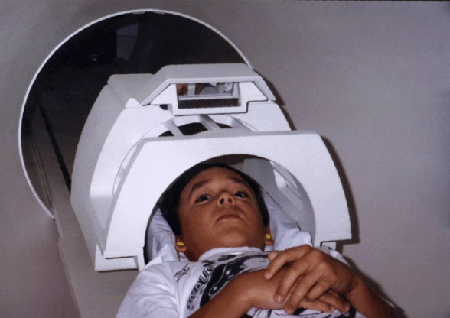
The evolved teenager
Some say bad choices are about exploring. They are about pushing limits. Experts believe exploring is an important part of growing up. It helps prepare teens to be adults. All through history, teens have done this. All over the world, teens still do.
Scientists found that mice do, too!
Young mice stay close by their mothers for safety. As mice grow, their behavior changes. They get more adventurous. But it seems to be a good thing. For example, young mice that explore the most also live longest.
A young boy prepares to enter a magnetic resonance imaging (MRI) scanner.
Gaming
What goes on in a teen’s brain? Brain scientists can’t look inside a living brain. So they scan brains while teens are thinking. They scan while teens are learning and making decisions.
Eveline Crone is a psychologist in the Netherlands. She studies how the brain develops. She uses a scanner. The scanner creates pictures of the brains of teen volunteers. It is painless and safe. Teen just lie back and play games.
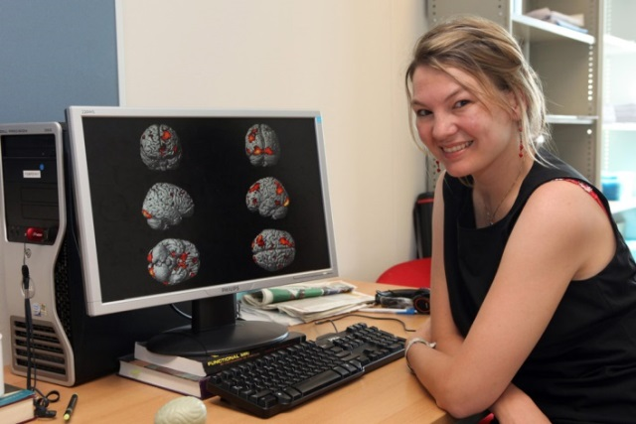
As teens look up, they see a computer screen. They play gambling games.
Teens also play games that require them to make choices. Some choices earn them coins or food.

While the teens play, researchers measure which parts of their brains are most active.

One region is more active in teens than in kids or adults. It’s the ventral striatum, the “reward center” of the brain. This region can drive us to repeat behaviors that provide a reward.
Psychologist Eveline Crone studies the teenage brain by observing which parts of it are most active when adolescent volunteers in an MRI scanner play casino-like computer games.
Tug-of-war
Teens are more sensitive to influence, researchers say. They respond to friends, desires and emotions,
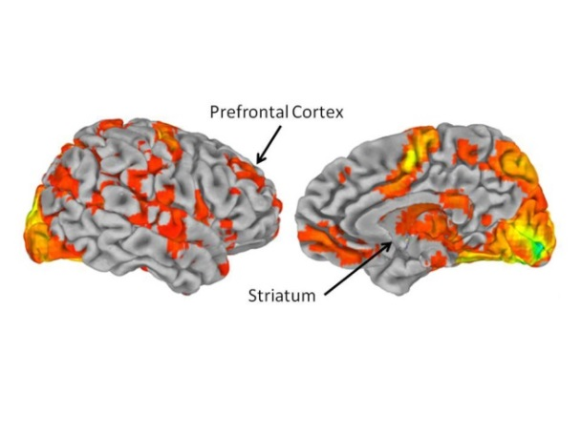
Why do teens often respond to influences with poor decisions? It’s a brain chemical called dopamine. The brain releases dopamine when something makes us feel good. It happens, for example, when we get a compliment or find a $20 bill. Dopamine levels are highest in teen years. That’s when this “feel good” response is very strong. That helps explain why teens often give in to impulsive desires.
B.J. Casey is a brain scientist at Cornell University. She’s discovered the ventral striatum is more active between ages 13-17 than at any other time in our lives. That’s the region that makes teens so impulsive.
These brain scans highlight the prefrontal cortex, just behind the forehead, and the ventral striatum, deeper inside the brain.
And she found something really important. The ventral striatum also communicates with another brain region. It’s just behind the forehead, the prefrontal cortex. The prefrontal cortex is the brain’s master planner.
The prefrontal cortex is the boss. It gives instructions and lets brain regions talk to each other. It guides how we think. It guides how we learn step-by-step procedures, such as tying our shoes. The prefrontal cortex’s ability to boss the brain grows as we get older.
Casey’s research shows the teen brain is in a tug-of-war. On one side is logic. On the other is impulse. Although teens can make good decisions, “in the heat of the moment — even when they know better,” the reward system can win over the master planner. That can lead to poor decisions, Casey says.
In fact, teens almost can’t resist the promise of a reward, Casey says.
Researchers believe the teen brain evolved this way so teens would leave the protection of home. They had to start exploring the world to become independent.
Improved chatter
The prefrontal cortex teaches the rest of the brain the rules about how the world works. When we’re teens, the prefrontal cortex slows down its growth. This is important, says Michael Frank of Brown University. During adolescence, it stays open to learning. In other words, it doesn’t say, “No!”
Before adolescence, the master planner of the brain isn’t advanced enough to guide all the other regions. Why? It still doesn’t know the rules of the game.
Pruned, not shriveled
The brain makes connections it really needs stronger. It eliminates those that aren’t useful. The changes give teens tools to start making their own decisions—even if they’re bad decisions, says Luna.
“Now you have a brain that says, ‘I can make my own decisions. I can skateboard down those steps,’” says Luna. “When you’re a kid, you’d check with Mom.”
All these processes explain the impulsive decisions that teen brains can make. Next time you wonder if a reward is worth the risk, remember the tug-of-war that’s taking place in your brain. Remember that somewhere in there, you have the tools to make the best decision.

1719 N Street, N.W. , Washington, D.C. 20036|© Society for Science & the Public 2000 - 2014. All rights reserved.

“Teen Brain” Power Words

adolescence: A transitional stage of physical and psychological development that begins at the onset of puberty, typically between the ages of 11 and 13, and ends with adulthood.
axon: The long, tail-like extension of a neuron that conducts electrical signals away from the cell.
evolve: To change gradually over generations.
magnetic resonance imaging (MRI): An imaging technique used to visualize internal structures of the body.
neuron: An electrically excitable cell that receives, conducts and transmits messages throughout the nervous system.
prefrontal cortex: The front portion of the brain, just behind the forehead, which controls executive functions in the brain.
synapse: The junction between neurons that transmits chemical and electrical signals.
synaptic pruning: The reduction in the number of neurons and synapses that begins in infancy and is mostly complete by early adulthood.
ventral striatum: A region deep inside the brain known as the brain’s reward center.

