Buckle up! Google will start testing driverless cars this summer
By Los Angeles Time, adapted by Newsela staff
June 06, 2014
Grade level: 7
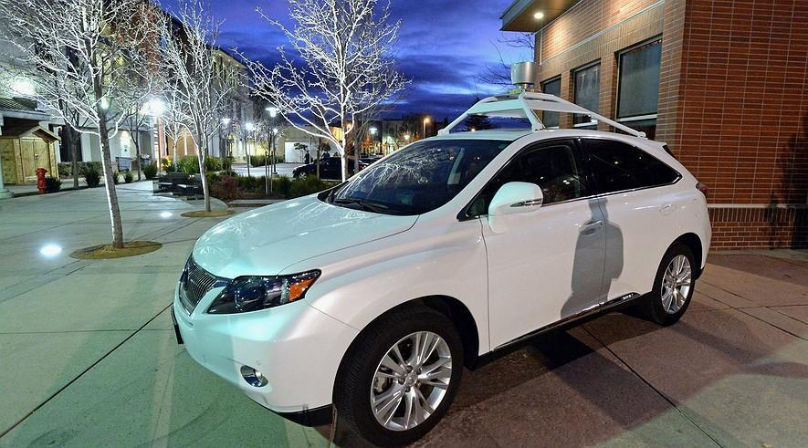One of Google's self-driving cars is on display in front of the Bankhead Theater in Livermore, Caliornia, Jan. 28, 2014. Photo: Doug Duran/Bay Area News Group/MCT
General Motors. Toyota. Google?
One of the world’s largest technology companies is getting into the car business and is hoping to turn drivers into passengers. Tech giant Google said on Tuesday that it plans to test about 200 of its own two-seat self-driving cars.
“We’ve been working toward the goal of vehicles that can shoulder the entire burden of driving,” the company wrote on its blog. “They will take you where you want to go at the push of a button.”
The main goal of the tidy, gumdrop-shaped cars isn’t to push Google into the business of building cars. Instead, the company wants to develop self-driving software that will “improve road safety and help people who can’t drive.”
Human Drivers Will Still Be In Control
The testing program will start later this summer, with a handful of early-stage self-driving cars hitting the roads around Google’s headquarters.
These early builds will have manual controls for the test drivers to override the cars’ self-driving systems as required by current California law.
But Google plans to build the bulk of the cars as fully self-driving. That means no steering wheel, no gas or brake pedal.
Inside will be a pair of seats with seat belts, space for your belongings, buttons to start and stop, and a screen showing where the car is going. California law is expected to allow the operation of such vehicles on public roads by the end of this year.
The cars were built with safety in mind. They have sensors that get rid of blind spots and look in every direction for more than 200 yards. The top speed of the first vehicles will be limited to 25 miles per hour (mph).
“We’re going to learn a lot from this experience, and if the technology develops as we hope, we’ll work with partners to bring this technology into the world safely,” Google said on its blog.
Google Will Drive The Car's Software
The small electric cars were built in Michigan using parts from suppliers to mainstream brands. The electronics and software to control them were assembled in Silicon Valley.
But don’t expect Google to take on the automakers directly.
“The chances of them getting into manufacturing are slim,” said Bill Hampton, publisher of AutoBeat Group. “I don’t think they want to do that. They want to control the information that will allow driverless cars to operate ... Figuring that out is worth a lot of money.”
Other analysts agreed.
“I can’t imagine Google would want to be in the low-margin manufacturing business,” said Egil Juliussen, the director of research and advanced driver assistance systems at IHS Automotive. “They would be the software provider, which can be the most profitable part of such a car.”
Google’s cars are also notable because their fully self-driving setup, which completely eliminates the driver, leapfrogs the step-by-step approach mainstream automakers have taken to self-driving cars.
Other Auto Companies Will Tailgate
Tuesday’s news probably will speed up development of self-driving cars at many of the largest automakers. These companies are most likely working on their own software. But smaller brands such as Subaru or Jaguar/Land Rover could look to license Google’s software for their vehicles.
Google’s plan to work on purely self-driving vehicles also turns the car from a product to a service. Self-driving cars could mean transportation for potentially billions of people who are unable to drive because of age, disability or income, Juliussen said. This change in thinking, from a company of Google’s stature, could ripple through the auto industry, he said.
In addition to possible partnerships with automakers, Google’s self-driving cars could spark micro-loan programs in cities similar to bike-share programs. Users could subscribe for a monthly fee, and take the cars when they needed them for short trips around town.
That change may happen faster than people think. Many automakers predict they will have fully self-driving cars on the road by 2020. By 2025, as many as 230,000 of these self-drivers could be sold each year around the world. And that number could swell to 11.8 million 10 years later, according to a study by Juliussen and IHS Automotive.
The Cars Will Not Be Cheap
As self-driving cars become more common, accident rates are expected to plunge to near zero, since a vast majority of today’s crashes are caused by human error, the study predicted.
Yet two key obstacles stand in the way of self-driving cars: cost and legislation.
Truly self-driving cars could cost $7,000 to $10,000 more than their manual counterparts when they hit the market in 2020. In addition, they probably will be available only as luxury models to begin with.
And U.S. laws have a lot of catching up to do. Currently only four states allow self-driving vehicles on public roads: California, Nevada, Michigan and Florida. Those that do require that a licensed, sober driver be in the driver’s seat at all times, ready and willing to assume control of the vehicle.
Google’s own car hopes to help the laws catch up to the technology.
“Just imagine: You can take a trip downtown at lunchtime without a 20-minute buffer to find parking,” Google’s blog said. “Seniors can keep their freedom even if they can’t keep their car keys. And drunk and distracted driving? History.”

Wanted: Small group to study space and travel to Mars. One way.
By Dallas Morning News, adapted by Newsela staff
May 22, 2014
Grade level: 8
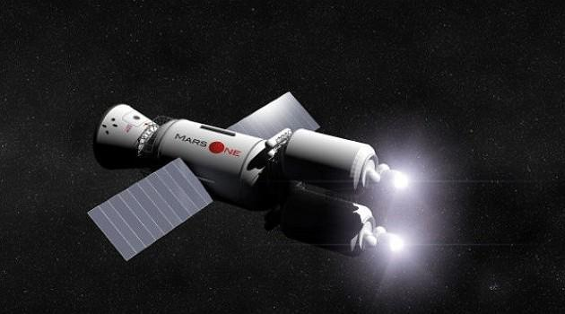A model of the space vehicle similar to what Mars One hopes to launch into space with its crew aboard. Photo: Mars OneDALLAS — Like many 20-somethings, Cole Leonard has reached a professional crossroads: Should he pursue a safe career — or strive for a dream that may prove to be elusive?
But few of his peers face a choice as extreme as his, a choice between becoming a lawyer — or dying on the surface of Mars.
It’s a difficult decision for the 27-year-old Plano, Texas, resident. Leonard has been accepted into law school at Texas Tech for the fall — but he is also one of 705 candidates vying to be part of the first human colony on Earth’s neighbor.
The journey is being organized by Mars One, a nonprofit founded by a Dutch businessman who insists it can be accomplished with current technology. The group began soliciting applications from potential colonists last year, and more than 200,000 people from around the world have already signed up. The list will be whittled down to 24 by next year, organizers said.
Space Living 101
Each colonist would undergo at least eight years of training. They’d learn about space travel and how to live on a planet with vicious dust storms, temperatures below minus 200 degrees and a lack of breathable air.
And there’s this one big catch: The technology doesn’t yet exist to launch a return flight — meaning, it would be a one-way trip for the colonists from Earth.
That sounds like a good deal to Leonard, though he doesn’t much fit the bill of an astronaut. He works as an aide to Dallas County Commissioner Mike Cantrell. The job consists of writing position papers, maintaining Cantrell’s website and brewing the occasional pot of coffee. Leonard doesn’t have much training in flight, engineering, agriculture, medicine or any other skills helpful to sustaining life on another planet.
But in other ways, he says, he’s perfect. He is young, healthy and single and has always been interested in space and science fiction. And, more importantly, he is deeply excited by the idea of exploring, and convinced of the need for humankind to broaden its horizons.
“For some reason, people think that exploration just ended when Columbus came over and found the West Indies,” he said.
Plus, he would leave behind an identical twin on Earth. “I’m expendable,” he said.
$6 Billion Excellent Adventure
Still, there’s some hesitation. Leonard says he doesn’t doubt Mars One’s sincerity, but he needs to be convinced that the group can pull off its grand idea. Before leaving Earth, he’d need to know more about the technology and contingency plans — after all, he’d hate to run out of food or power or water 34 million miles from home.
Mars One officials declined to comment. Founder Bas Lansdorp, who made his fortune building a wind energy company, has estimated that it will cost $6 billion to send the first group of four to Mars. He hopes to raise much of that through a worldwide reality television show, which would broadcast the training, the trip and the landing.
You're Joking, Right?
Leonard has simpler worries, too. He can’t study to become a lawyer and train to be an astronaut at the same time — and he’s hesitant to give up law school for a dream that may not pan out.
Plus, he’d miss music and simple, everyday things like relaxing outdoors on a patio. There are still lots of places on Earth he hasn’t seen — and, of course, there’s his family, who don’t want him to go.
“They flip between denial, to anger, to disgust, to thinking it’s all a joke,” Leonard said.
His twin, Mitchell, said that’s not completely true. The family believes he's a good candidate — they just don’t want him to leave the planet, or to regret his decision as he journeys through space.
“The whole family knows that Cole can get picked,” said Mitchell, who is planning to room with Leonard in Lubbock, just as he does now in Plano. “They already see him flying off into the sky.”
Leonard said he understands that law school would be a more practical choice — and one that might prolong his life. But certain death on Mars doesn’t scare him, he says, because death is certain everywhere.
If he becomes a lawyer, he said, “I am going to die here in some crappy retirement home in Florida.” If he's going to die anyway, he feels, why not do it somewhere exciting? “Why not Mars?”

As hospital equipment goes online, hackers see potential new targets
By Medill News Service, adapted by Newsela staff
May 19, 2014
Grade level: 8
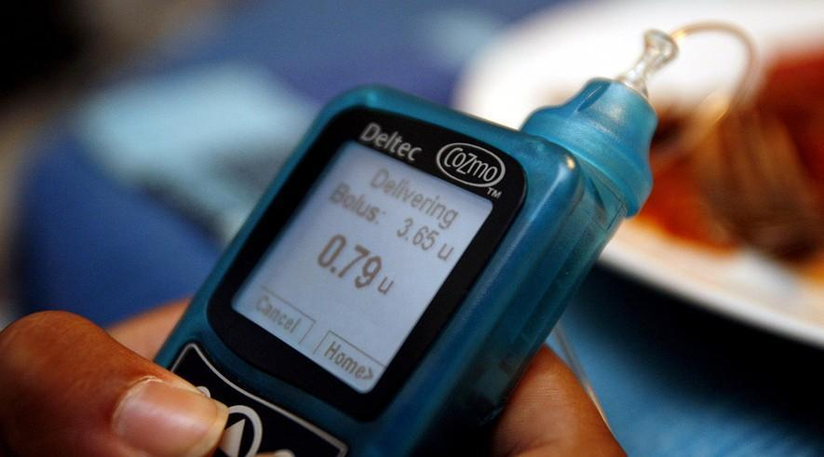Jasmine Amerasekera uses the insulin pump to calculate blood sugar levels and carbohydrates to work out the amount of insulin that is injected into her body before dinner at their home in Dallas. Photo: Melanie Burford/Melanie Burford/MCT
WASHINGTON — Chris Carroll won’t forget the first time he saw someone hack into an insulin pump and make it deliver a deadly dose.
The pump wasn’t connected to anyone. Still, Carroll, a 34-year-old from Austin, Texas, got the point: The danger was real.
It hit home, too. Carroll has Type 1 diabetes and wears a pump that delivers insulin directly into his body.
More and more medical devices and hospital equipment are becoming connected to the Internet or networks. That means they may become targets for criminals or hackers trying either to harm the users or make points about their own technological skills.
“The health care industry is not technically prepared to combat against cyber criminals’ basic cyber-intrusion tactics,” an April report from the cyber division of the FBI says. It also says the industry is not as prepared for cyber attacks as the financial institutions and and retailers. "Therefore the possibility of increased cyber intrusions is likely.”

Accidents Could Happen Too
Experts also are worried about the potentially deadly results of unsecured systems being violated accidentally. As people become more dependent on medical devices that share information, the chance increases that their codes could be scrambled, causing malfunctions.
“I think the thing we really have to worry about the most,” said Frank Painter, a health care technology consultant, “is an unsecure system being able to be violated by accident.”
The technology magazine Wired reported in April that an information security official from Essentia Health found that cyber intruders can take over drug infusion pumps — which deliver antibiotics and chemotherapy directly into patients — defibrillators and X-rays. They can even change temperature settings on medical refrigerators that store drugs and blood.
The security official, Scott Erven, had access to a chain of health care facilities in the Midwest over two years for the study, Wired reported. Erven couldn’t be reached for a comment for this article.

Big Market For Health Records
As hospitals move patient records to network databases, the financial incentive for hackers is huge. The FBI report notes that even partial electronic health records are selling for $50 each on the black market. Social Security cards and credit card numbers only fetch $1 apiece.
Electronic health records contain comprehensive patient information. This allows all the patient’s health care providers to share that information. These records are attractive targets to hackers because they can be used to sell drug prescriptions.
Michael Carome, the director of health research at Public Citizen, a consumer rights group in Washington, said the risk of private medical information leaks was hard to quantify. But “it is a concern and it should be on the radar screen of public health officials and those who are responsible for security.”
Since the Affordable Care Act encourages physicians to adopt electronic health record keeping for their patients, greater security provisions are needed, Carome said.

Companies Are Stumped
The FBI report cites research from the SANS Institute, a private company that specializes in Internet security training. SANS concluded that some systems and devices were compromised for extended periods, and that companies, when notified of the vulnerabilities, did not repair them.
“The time to act is yesterday,” the report says.
Carroll is familiar with manufacturers’ indifference to security concerns. After he saw the insulin pump hacking demonstration, he contacted his own pump provider.
“Both of the people I talked to had no idea this was possible, and had no answer regarding plans to fix the issue,” he said. “They tried the whole, ‘Well, even if it’s possible, no one would do it.’”
So far Carroll’s pump manufacturer has been right. The Food and Drug Administration’s (FDA) website says the agency isn’t aware of any patient injuries or deaths related to hacking.

So Many Devices, Not Enough Time
Still, at least some users think the risks are real. As early as 2007, then-Vice President Dick Cheney had the wireless function on his heart defibrillator disabled. He feared it put him at risk of a terrorist attack. But most people don’t face the same level of personal risk.
“I hold no delusions of grandeur that I’m important enough for people to go after, but I do know that some people try these types of things just for the hell of it,” Carroll said.
Typically, problems with medical devices are identified by or reported to the FDA. But the quickly growing number of new devices calls into question the FDA’s capacity to monitor medical devices.
“There are so many different kinds of inventions and devices doing so many different things, the FDA really can’t legislate down to the line and code of security for every situation,” said Painter.
Painter also said the FDA’s general standards were sufficient. The responsibility for ensuring device security lay with the manufacturers, he said. “Good designers can build good, safe, secure designs in the first place, pretty simply. So if they did that, it would preclude somebody from doing something bad.”
In an email, the FDA referred to an online statement about when it allows devices to be marketed. They let the devices be sold “when the probable benefits to patients outweigh the probable risks.”
Like Painter, the FDA maintains that ultimately it is the manufacturers' responsibility to find risks associated with medical devices. This includes “risks related to cyber security."

The "Minecraft" miracle: teachers tell students to go play a video game
By Chicago Tribune, adapted by Newsela staff
May 08, 2014
Grade level: 8
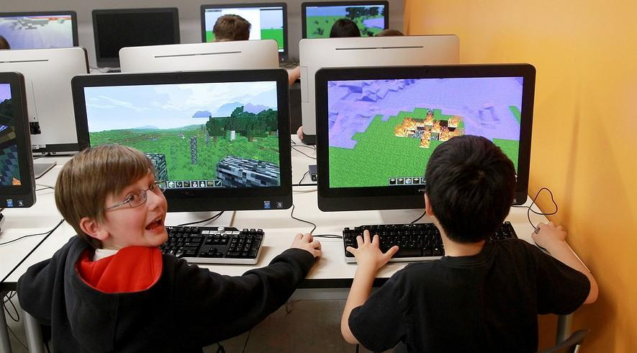Bobby Craig (left) and Doogy Lee create worlds in "Minecraft" that parallel what they have been reading in "The Hobbit" as part of their fifth-grade class studies at Quest Academy in Palatine, Ill. Photo: Chuck Berman/Chicago Tribune/MCT
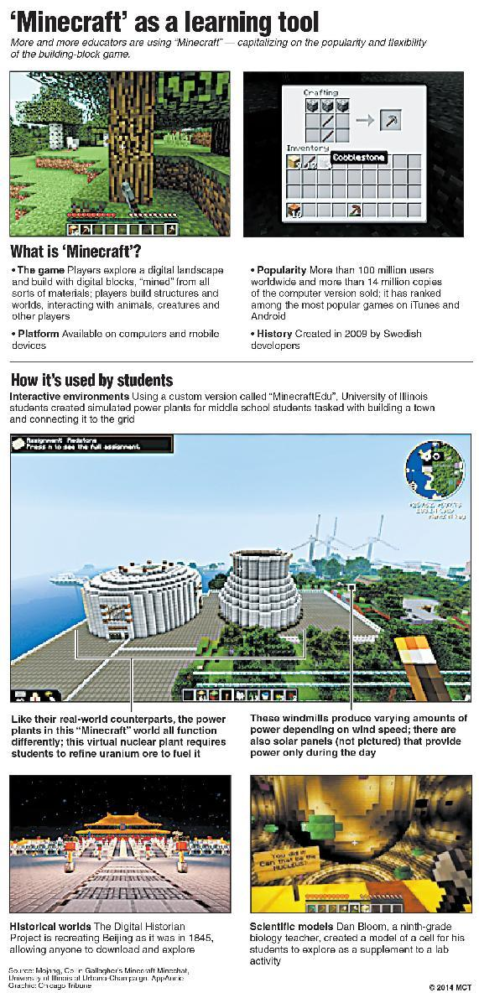
CHICAGO — A handful of seventh-graders at Northbrook's Maple School sat down at the school’s library computers recently to strengthen their understanding of the Cold War.
They weren’t scouring Wikipedia for historical information or going through old news footage on YouTube. Instead, they were building a model of Germany with the help of one of the world’s hottest video games: "Minecraft."
“It’s really a great visual tool for presenting our knowledge, just like you would use something like PowerPoint to show off your research,” said Arie Estrin, 12, assembling a nuclear submarine, block by digital block. “That’s what we do with 'Minecraft.' It’s a good way to channel your thoughts into understanding how something might have actually looked or happened.”
A game like "Minecraft" might seem better suited to the family room than the classroom. But more and more teachers are tapping its creative power to educate students in subjects from history to engineering to science.
It’s part of a movement that aims to inspire kids through familiar and beloved technology. Teachers are using games such as “Assassin’s Creed” to illustrate the Revolutionary War and “World of Warcraft” to get kids interested in creative writing. But nothing has had the impact of "Minecraft," which has more than 100 million registered users worldwide.

"It's Virtual Legos"
“It’s virtual Legos,” said Zack Gilbert. He is a sixth-grade teacher in Normal, Ill., who hosts a podcast on gaming in education. When parents question him about using video games in class, he asks them if they played Legos as a kid.
“That’s what this is, except it’s virtual and there’s more building and creating than you could ever do (in the real world)," he said.
"Minecraft" was the brainchild of Markus Persson. He is a Swedish game designer who loves the simple graphics and open-ended play of the games he played when he was young. Released in 2009, "Minecraft" lets users build almost anything they can imagine out of multicolored cubes.
The results can be stunning. YouTube is filled with guided tours of highly detailed "Minecraft" worlds. The worlds range from university libraries and New York City skyscrapers to the fantasy lands of “Game of Thrones” and “Harry Potter.”
Northwestern University student Ben Rothman spent hundreds of hours recreating the school’s campus on "Minecraft" two years ago.
“The main driving force was that I noticed that I had been spending 20 hours a week playing video games,” said Rothman, 22. “I figured, ‘I’m going to do this anyway. Why don’t I do something that will let me play but also get something out of it?’”
That pretty much sums up why "Minecraft" has caught on at hundreds of schools worldwide. Joel Levin is a former teacher who helped create a version of the game for educators. He said his young daughter picked up sophisticated math skills such as estimation and proportion by building a "Minecraft" house.

"The Secret Sauce"
“The secret sauce is that kids are engaged,” said Levin, whose company, TeacherGaming, has sold the "MinecraftEdu" version of the game to 2,500 schools worldwide. “They love it. They want to do it.”
Some kids want to play it so much that they sign up for weekend or summer classes that use "Minecraft." Dana Stewart, who teaches a course for Northwestern’s Center for Talent Development, has her students build ancient Egyptian structures with the game. The project makes them consider design issues and available building materials.
“It’s an experience you can’t replicate any other way,” Stewart said. “It’s kind of, sort of, like walking through it in real life.”
Jana Sebestik, who works at the University of Illinois, had his middle school students build houses that are on the same power grid.
The idea is to use a game that kids love to introduce them to real-world science and engineering problems and to awake an interest in the subjects.
“Middle school is the place you can catch a kid and create enthusiasm,” she said.
Quest Academy, a private school in Palatine, Ill., has incorporated the game into a fifth-grade class this year. They use it to reinforce lessons on J.R.R. Tolkien’s “The Hobbit.” Since November, students have been building their own fantasy worlds — designed to be populated by virtual dragons — and writing about the adventures they have there.

Creativity Run Wild
Amelia Landau, 11, said the game has allowed her to let her creativity run wild.
“'Minecraft' is a nice way to make your imagination fly a little bit better,” she said. “If you want to create a huge sculpture, you can do that easily with thousands upon thousands of materials.”
Some academics wonder, though, if "Minecraft" will be limited to wealthy districts with high-achieving students.
Maria Cipollone, who is getting her doctorate at Temple University, recently used the game in a research project at a Philadelphia public school.
She found that the game helped the students develop math skills such as estimating proportions. But it didn’t translate into the sort of math ability that would boost standardized test scores.
But Dan Rezac, a technology specialist at Maple School in Northbrook, said that when kids do get a chance to play, the results can be amazing.
“With 'Minecraft,' they can build anything,” he said. “They can learn social skills so they can work together with other people, who may not be in the same room, to build worlds and lands and objects, or, as one of our kids was saying, to re-create the human body so they can test diseases on it. There are really just limitless possibilities.”

From gadget to garbage: tackling the problem of discarded technology
By Orange County Register, adapted by Newsela staff
Jan. 13, 2014
Grade level: 8
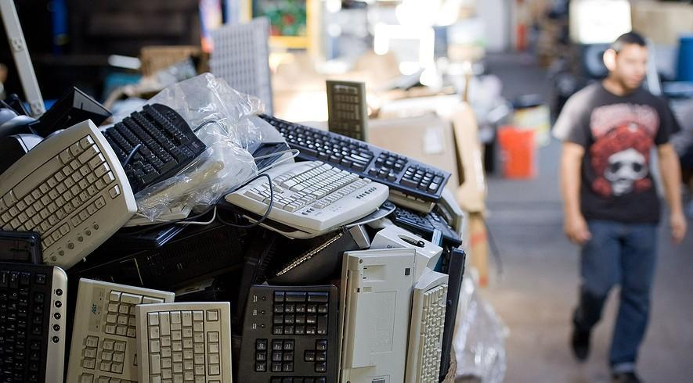Old computer keyboards fill a box as EXPC employee Diego Cuellar walks through the company's warehouse on Dec. 17, 2013, in Santa Ana, Calif. In California, e-waste is recycled with funds paid by consumers as a fee when they purchase electronics. Photo: Mindy Schauer/Orange County Register/MCT
Christmas gifts of years gone by meet a sad end at Absolute Green Electronics Recycling in California. Computers are dismantled, the parts sorted into cardboard bins. One holds nothing but hard drives, another AC adapters. Bins stretch in rows across a huge warehouse. There are bins for cellphones, VHS camcorders, digital cameras, cables and network switches.
Stacked-up printers form a miniature mountain. Old-fashioned picture tube TVs sit face-down on pallets. Flat-screen monitors cluster along a wall like tombstones.
“There are different grades of boards,” said owner and president Victor Kianipay, stepping past huge, dust-covered projection TVs to poke into apple boxes filled with circuit boards. “Everything gets separated,” Kianipay said. “There are so many layers and layers of product.”
This is electronic waste, or e-waste. It's a source of income for Kianipay. He moved 25,000 pounds of discarded items in last January’s post-Christmas frenzy.

Stopping "Digital Dumping"
E-waste also is an environmental problem of global proportion. The ever-rising tide of electronic junk now totals nearly 50 million tons a year worldwide, according to the Solving the E-Waste Problem Initiative, a coalition of governments, scientists and industry groups based in Bonn, Germany.
Within five years, the annual figure may reach 65 million tons — enough to fill trucks parked bumper to bumper encircling three-quarters of the Earth, the coalition estimates. The waste is a particular concern in part because much of it contains lead, mercury and other hazardous substances. Those substances are released when the waste is melted down to recover gold, silver and copper.
The widespread practice of exporting electronic waste to developing countries has created a bustling scrap metal business in poor parts of China and Africa. But it has also exposed large numbers of people to poisonous toxins and carcinogens.
“You see all these thousands — literally thousands — of women and young kids whose job is to cook circuit boards,” said Jim Puckett, founder of the Seattle-based Basel Action Network. The group is named after the Swiss city where international agreements were drafted in the late 1980s and early 1990s to stop the “digital dumping.”
Although 35 nations have adopted the principles of the Basel Convention, Puckett said, the United States — by far the largest producer of e-waste — has not.
The U.S. Environmental Protection Agency, in a report posted on its website, said “most discarded consumer electronics end up in our landfills.” That's a completely separate environmental problem. No one is sure how much e-waste ends up being exported from the U.S., the EPA says, but “the United States government is concerned that these exports are being mismanaged abroad, causing serious public health and environmental hazards.”

California's Recycling Incentives
Puckett, who has spent years investigating the issue, estimates that “about 50 to 80 percent of what is handed over to recyclers is exported.”
Spurred by environmental activists, Congress and state governments are trying to ensure that e-waste gets properly recycled here. The federal Responsible Electronics Recycling Act was introduced in July. If passed, it would prohibit the export of electronic junk containing toxins to nations that cannot process them safely.
In addition, President Barack Obama established a task force in 2010. Its role is to encourage development of “greener” electronic devices and to boost domestic recycling.
California became a national pioneer by enacting the Electronic Waste Recycling Act of 2003. The law created a system of incentives to prevent the disposal of most video-display devices and certain other types of electronic equipment in landfills. The law especially targets outmoded picture tube TVs and computer monitors — not flat screens.
The old TVs are particularly bad because they contain both lead and mercury, said Mark Oldfield. He's a spokesman for the state’s Department of Resources Recycling and Recovery.
More than 1.5 billion pounds of video-display equipment has been collected directly because of the law since 2005, Oldfield said.

An Explosion Of Devices
Inside a cluttered warehouse at EZPC Recycle in Santa Ana, Calif., owner Chris Chun has a workbench where his staff tests discarded computers and network switches. Devices that still work are sold on the secondhand market. Computers are offered at a steep discount to schools and churches.
“I have kids. I want them to have a clean, safe environment,” said Chun, a father of two boys. If electronic equipment gets tossed into a dump, “it just stays there,” Chun said. “It’s never going to decompose.”
Still, e-waste is never particularly easy or clean even when handled properly. Taking apart some equipment requires removing up to 50 screws, Chun said.
Industrial-scale shredders turn circuit boards and hard drives into huge bits of glass, metal and plastics. Those pieces have to be melted in a smelter to isolate the gold, silver, copper and palladium, said Ted Smith, founder of the San Francisco-based Electronics TakeBack Coalition.
“There are no smelters that do this in the U.S.,” due to the environmental effects of the smelting process, Smith said. Therefore, the shredding companies “send the metals by rail car all the way to northern Quebec, where there is a smelter.”
So far, nearly half the states have passed e-waste recycling laws. But, environmentalists fear they are only losing ground because of the astonishing explosion of devices.
Consumers upgrade their cellphones even when the old ones still function. Whole classes of gadgetry have come into being, such as GPS systems and Google Glass.
“Four hundred million gadgets a year get thrown away in this country,” said Annie Leonard, founder and president of The Story of Stuff Project in Berkeley, Calif. Nationally, she said, less than one-fourth gets recycled. “The way we make, use and throw away products in this country is a cause for national embarrassment.”

