Reading Part A
Reading Part A, continued

Too Much Sugar in Beverages
Adapted from http://www.caffeineinformer.com/sugar-in-drinks
Compiling this list surprised us – the most sugar filled drinks are not what you think they are.
In a number of drinks the level of sugar is huge. No wonder soft drinks play such a big role in obesity. The average American consumes around 150 pounds of refined sugars a year.
Some drinks and juices have as much sugar as several Snickers candy bars. Sugary beverages contribute to the Type 2 diabetes crisis in our country. 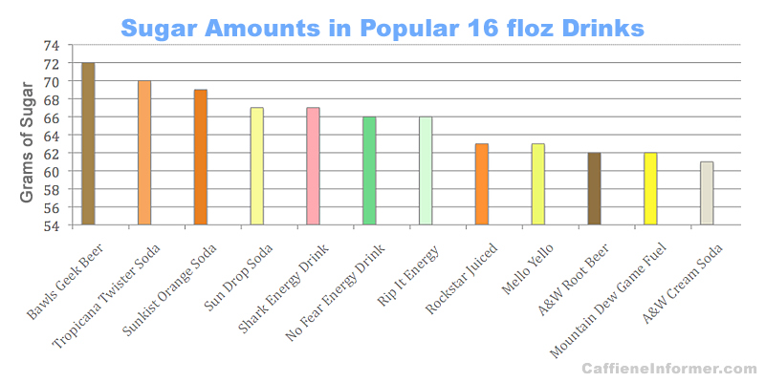

A recent study at Maquarie University showed that sugar and caffeine when combined and fed to rats produced lasting changes to brain chemistry.

Researchers from the University of California in San Francisco found that those who drink just 20 fl.oz. of sugary soda a day may take as much as 4 years off of their lifespan.

Why is so much sugar placed in drinks?
- Caffeine is bitter. Most people add sugar to caffeinated beverages (like coffee or tea) to make them drinkable.
- Energy Drinks contain caffeine. They also contain lots of sugar. A typical 16 fl. oz. energy drink contains around 50-60 grams of sugar. This is about 10-12 teaspoons of sugar.

Writing Part B

Writing situation:
To improve our health and reduce obesity, our state legislature is considering a new law that would tax sugary beverages. Is this a good idea or not? Should the government have a role in improving our health? Or is it up to the individual?

Writing directions:
Read/listen to the passages about taxing sugary drinks. Choose your position on the issue. Then write a letter to the governor stating whether Kentucky should tax sugary drinks or not. Use evidence from the articles to support your argument.

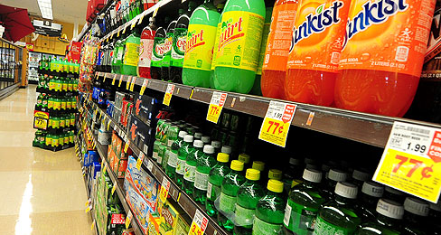
Should sugary drinks be taxed?
Reading Part A
November 10, 2014
By Brenda Iasevoli
Retrieved 4-20-15 from http://www.timeforkids.com/news/debate/192101 (7.6)

Over the years, many cities and states have tried to pass a tax on sweetened beverages. In November, Berkeley, California succeeded. The city in northern California will charge a penny-per-ounce tax on most sugary drinks. The tax is expected to raise more than $1 million annually to combat obesity.
Makers of soda and other sugary drinks are against the tax. They say singling out one product will not solve the obesity problem in America. They also argue that a tax is an attack on personal freedom.
Sweetened beverages are the biggest source of added sugars in the American diet. High intakes of sugar can lead to obesity, heart disease, Type 2 diabetes, and other health problems. Supporters say a tax is a surefire way to help reduce obesity in the U.S.
Too much refined sugar in the diet is linked to many health problems. High intakes of sugar can lead to obesity, heart disease, Type 2 diabetes, and other health problems such as tooth decay. “This is the first generation of children who won’t live as long as their parents,” Dr. Rachel Johnson told Time for Kids. She is a spokesperson for the American Heart Association.
What do you think? Should sugary drinks be taxed?
______________________________________

- Listen to the PBS News Hour Broadcast: http://www.pbs.org/newshour/bb/health-jan-june12-sodatax_06-07/

Should Sugary Drinks Be Taxed Like Cigarettes? Calif. City Considering Idea
June 7, 2012 at 12:00 AM EDT (9.7)

