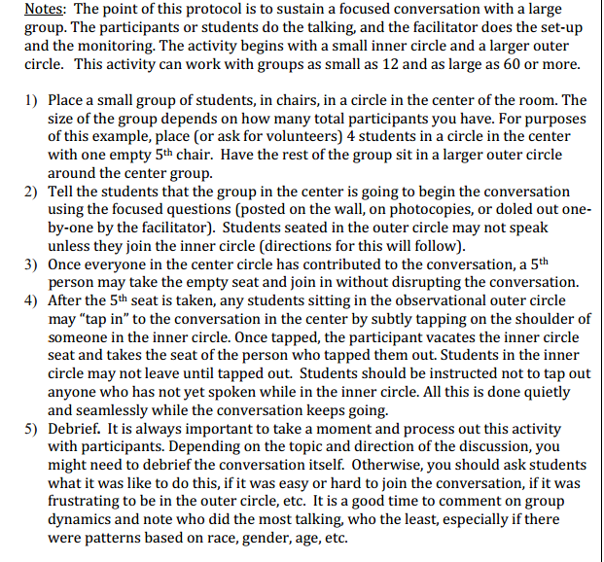
This protocol is one of many protocols that have been compiled by the Common Instructional Framework (CIF). The protocols can be found here: http://raiders.psjaisd.us/ourpages/auto/2013/9/28/44120924/CIF_Protocols.pdf

