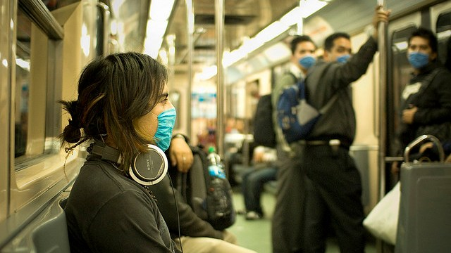
Should Cold Sufferers Wear Medical Masks?
Science Friday | January 20, 2015 |
Adapted 8.7

Credit: Eneas De Troya

Chances are, you’ve had the symptoms of a common cold: coughing, sneezing, runny nose, sore throat and headache. Every year, millions of Americans come down with a case of the common cold. Most people suffer two or three colds per year, on average. This results in many missed days of school and work. Unlike bacterial infections, the common cold cannot be cured with antibiotics. In some cases colds can become serious. For small children and the elderly, catching a cold can lead to serious complications, including respiratory tract infection and pneumonia.
Though “the common cold” sounds like a single illness, it has been associated with over 200 different viruses. These viruses are transmitted mainly by inhaling and ingesting tiny droplets containing the virus. These droplets, called aerosols, are produced when an infected person sneezes or coughs. Another common mode of transmission is called “self-inoculation.” This occurs when a person infects himself by touching a virus on a surface, and then touching his eyes, nose or mouth.
Even though humans have adopted many ways to limit the spread of cold viruses, the common cold is still common. Making someone with a cold wash her hands and cover her mouth with a tissue when sneezing can reduce the amount of virus in the environment. However, these methods are not 100 percent effective. People touch their faces constantly, about once every four minutes. They can transfer a small amount of infected saliva or mucus to shared surfaces like doorknobs or railings and potentially infect someone else.
Medical face masks, like the ones worn by surgeons and healthcare workers, are increasingly used by cold and flu sufferers to decrease the spread of illness in public spaces. They are very effective in preventing virus transmission. They are often used by nurses and doctors during emerging disease epidemics to protect themselves. Facemasks prevent the spread of aerosols from sneezes and coughs. They also prevent hand-to-face contact that could spread a virus to surrounding surfaces. Though they are fairly inexpensive, they can be hot and uncomfortable. This discourages people from wearing them constantly. Some also fear that medical masks call attention to their illness. They choose not to wear them to avoid being singled out.

DO NOW:
What do you think? Should cold sufferers be encouraged to wear medical masks to help prevent spreading germs? Would you wear one the next time you have a cold?

