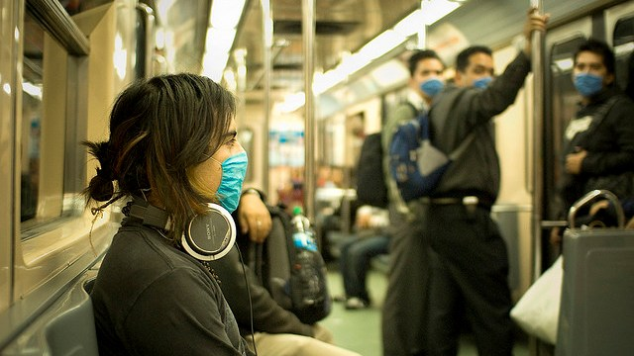
Should Cold Sufferers Wear Medical Masks?
Science Friday | January 20, 2015 |

Credit: Eneas De Troya

Chances are, you’ve experienced the symptoms of a common cold: coughing, sneezing, runny nose, sore throat and headache. Every year, millions of Americans come down with a case of the common cold, suffering two-three colds per year, on average, and resulting in many missed days of school and work. Unlike bacterial infections, the common cold cannot be cured with antibiotics and in some cases can become serious. For small children and the elderly, catching a cold can lead to serious complications including respiratory tract infection and pneumonia.
Though “the common cold” sounds like a single illness, it has been associated with over 200 different viruses. These viruses are transmitted primarily through inhalation and ingestion of tiny droplets containing the virus – called aerosols – that are produced when an infected person sneezes or coughs. Another common mode of transmission is called “self inoculation” and occurs when a person infects himself by touching a virus on a surface, and then touching his eyes, nose or mouth.
Even though humans have adopted many methods of limiting the spread of cold viruses, the common cold remains, well, common. Making someone with a cold wash her hands and cover her mouth with a tissue when she sneezes can reduce the amount of virus in the environment, but these methods are not 100 percent effective. Because people touch their faces constantly (about once every four minutes), they can transfer a small amount of infected saliva or mucus to shared surfaces like doorknobs or railings and potentially infect someone else.
Medical face masks, like the ones worn by surgeons and healthcare workers, are increasingly used by cold and flu sufferers to decrease the spread of illness in public spaces. They are highly effective at preventing virus transmission, and are used frequently by nurses and doctors during emerging disease epidemics to protect themselves from illness. Facemasks work by preventing the spread of aerosols from sneezes and coughs, and also by preventing hand-to-face contact that could spread a virus to surrounding surfaces. Though they are relatively inexpensive, they can be hot and uncomfortable to wear, thus discouraging people from wearing them constantly. Some also fear that medical masks call attention to their illness, and choose not to wear them to avoid being singled out.

DO NOW:
What do you think? Should cold sufferers be encouraged to wear medical masks to help prevent spreading germs? Would you wear one the next time you have a cold?

