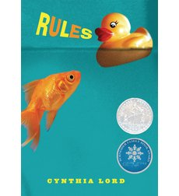

Rules

By Cynthia Lord
Interest Level: Grades 3 - 7
Reading Level: Grade level Equivalent: 4.5; Lexile® Measure:780L; DRA: 40; Guided Reading: R
Theme/Subject: Living with Illness and Disabilities; Siblings; Friends and Friendship; Autism; Physical Disabilities
Reading Quiz Programs

Free Teaching Resources
Rules Storia Teaching Guide
Rules Booktalk

About This Book
This 2007 Newbery Honor Book is a humorous and heartwarming debut about feeling different and finding acceptance.
Twelve-year-old Catherine just wants a normal life. Which is near impossible when you have a brother with autism and a family that revolves around his disability. She's spent years trying to teach David the rules — from "a peach is not a funny-looking apple" to "keep your pants on in public" — in order to stop his embarrassing behaviors. But the summer Catherine meets Jason, a paraplegic boy, and Kristi, the next-door friend she's always wished for, it's her own shocking behavior that turns everything upside down and forces her to ask: What is normal?
Newbery Honor Medal
Schneider Family Book Award
ALA Notable Children's Book

About the Authors or Illustrators

Cynthia Lord
Cynthia Lord is the author of Rules, Touch Blue, and Hot Rod Hamster. She lives in Maine.

