Be sure to check that the cover sheet on this prompt packet matches the one you read about yesterday.
Please fill out any missing identifying information on this cover sheet in PRINT (not cursive)

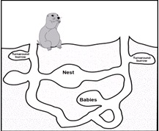
E

Prompt:
Redesigning High School for Career Success?

Student first name: Student last name:

Teacher name: Class period:

Grade level:
8th 9th 10th

PROMPT FOR WRITING

E. Redesigning High School for Career Success?

Some politicians and educators say that we should change high school so that young people are better prepared for work. What do you think your state’s Department of Education should do about changing high schools to prepare young people for work? Why?

Write an argument. Use ideas and evidence from the reading packet to support your argument. Use what you have learned about citing and quoting sources in your writing

The audience for your argument is the Director of your state’s Board of Education.

DIRECTIONS
- Take five minutes to review your reading packet, notes and planning page from Day 1.
- Use the space on the next page if you want to plan and organize before you write.
- Begin writing your argument on page 3. Use as much space as you need to complete your argument.

PLANNING YOUR WRITING (optional)

START WRITING HERE

IF YOU NEED ADDITIONAL SPACE TO WRITE, get lined paper from your class and staple to this packet when you’re done writing.

