PRO/CON: What should students have for lunch?
By McClatchy-Tribune News Service, adapted by Newsela staff
09.29.14
Lexile: 790
Word Count 1,085

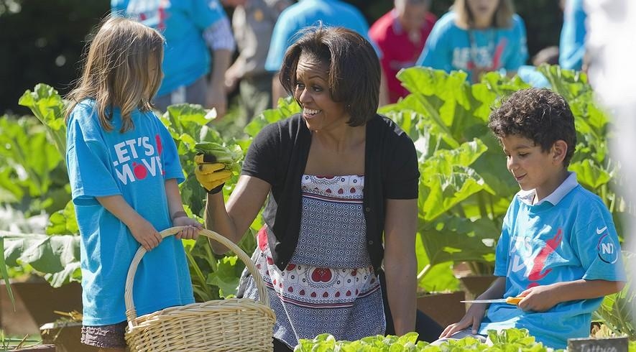First lady Michelle Obama tends the White House garden in Washington, D.C., with a group of children as part of the "Let's Move!" campaign. Photo: AP Photo/Evan Vucci, File
PRO: Putting healthier food on students' lunch trays
WASHINGTON — As a new school year begins, American parents should support first lady Michelle Obama. She has a new plan to make school lunches healthier. It is based on science and nutrition.
The first lady wants to improve children's health through better eating and more exercise.
America has a weight problem. Many people aren't just overweight, they are obese. Childhood obesity is a national problem: In 2012, 1 in 3 American children were overweight or obese. Overweight children may develop diseases, including heart disease and diabetes.
The U.S. has had a national school lunch program since 1946. It helps pay for school meals. More than 30 million students benefit from it. Yet over the past 15 years, the program hasn’t changed much. Obama wants to update it as part of the Healthy, Hunger-Free Kids Act.
Fewer Calories, More Whole Grains
The Institute of Medicine is a group of scientists and health experts. It has pushed for healthier school meals. It recommends meals containing fewer calories, less fat and salt, and more fruit, vegetables and whole grains. Most parents would agree these are excellent goals.
The new law also makes it easier for poor kids and foster kids to have school meals. It helps pay for their meals.
However, the government only sets guidelines. Each school system then makes its own menus. You also shouldn't believe ridiculous rumors. No matter what people say, there is nothing in the law that prevents bake sales or birthday cakes in the classroom.
Still, there have been small problems. For instance, many high school athletes needed more protein than the guidelines allowed, so the government changed the rules.
Most school systems are working with the rules. Nine out of every 10 now meet the new guidelines. Studies show most kids now like the new, healthier choices.
Kids Will Enjoy Healthy Food
But, some people don't want to improve the law. They just want to attack it. Health food supporters think junk-food sellers want to stop the new rules. They say junk-food sellers are trying to push our leaders in Congress to stop any changes in the law. There have been talks in Congress to hold off on the new nutritional rules for a year.
Kids avoid healthy food, but with enough time they come to enjoy it. School systems that made the changes slowly found students more ready to accept them.
The government has given food and money to our schools to improve student nutrition for years. It has been good for the kids, good for education and good for our country. Over the years, aid has helped kids afford breakfast as well as lunch.
Obama’s plan is just the newest effort to make sure our kids eat right at school. Every parent should support it.
———
ABOUT THE WRITER: William Rice is a policy specialist with Americans for Democratic Action (www.adaction.org), the nation’s oldest liberal advocacy organization. Readers may write him at ADA, 1629 K Street NW, Washington, DC 20006.
This essay is available to McClatchy-Tribune News Service subscribers. McClatchy-Tribune did not subsidize the writing of this column; the opinions are those of the writer and do not necessarily represent the views of McClatchy-Tribune or Newsela.
CON: Keep government out of the school cafeteria
WASHINGTON — Our national school meal program should meet the needs of students. To do that, parents must be allowed to decide what’s best for their children. First lady Michelle Obama has pushed for new changes to the program. She seems to think our government knows better than parents.
Unfortunately, new school meal rules ignore parents. The first lady pushed for the Healthy, Hunger-Free Kids Act of 2010. Its new rules started to go into effect two years ago.
Many people do not agree with the rules.
The School Nutrition Association represents more than 55,000 school nutrition experts. It sent a letter to the first lady expressing “disappointment." The group said she made comments that put down school nutrition workers.
Worries About Wasted Food
The new meal rules try to control everything about school meals. They control calories, nutrition in meals and meal sizes. Some schools have left the program. They would rather not get the huge amounts of money the government offers, to avoid all the government's rules.
Our government claims that parents need help. It believes parents can’t make sure their kids eat properly at school. Of course, parents can’t know every single thing that their children eat at school. Yet this doesn’t mean parents haven’t taught their children how to make the right choices.
The new rules don’t let states and school leaders have enough say. They don't give them the freedom to deal with the concerns of parents.
If they did, it would help officials better meet the needs of their students. Not only that, but it would also give parents more say in the food provided through meal programs.
The rules have been criticized by nutrition experts. The Government Accountability Office investigates issues for the government. It surveyed state nutrition officials. It found that officials had concerns about the lunch rules. There were worries about wasted food and the costs of meeting the new rules. The rules make lunches cheap for students, but they cost schools money.
Students Don't Like The Lunches
The National School Board Association said, “school boards cannot ignore the higher costs" created by the rules. Some schools have reportedly even taken money away from teacher pay to cover the extra costs.
Worse, students are disgusted by the food provided to them. The GAO report said that students in one district refused to eat school lunches for three weeks. Students are posting their anger over the program using Twitter at “#ThanksMichelle.”
The first lady and other supporters of the rules haven't listened to complaints. They’ve even opposed giving some poorer schools a one-year break from going along with the rules. Nothing, it seems, will be allowed to slow it from taking effect.
And that’s a shame. The meal rules aren’t fit for our kids. They need to be stopped.
———
ABOUT THE WRITER: Daren Bakst is a research fellow in agricultural policy at The Heritage Foundation, (heritage.org), a conservative think tank on Capitol Hill. Readers may write him at Heritage, 214 Massachusetts Ave. NE, Washington, DC 20002.
This essay is available to McClatchy-Tribune News Service subscribers. McClatchy-Tribune did not subsidize the writing of this column; the opinions are those of the writer and do not necessarily represent the views of McClatchy-Tribune or Newsela.

