Using Source Material -- Student Response Tool

Student Writer’s Name: ______________________________________________________
(Write the Name of the Student Who Wrote the Paper Here)

Writing Topic: _____________________________ Today’s Date: __________________
What is the writing about?

Using source material is a key move in college and career writing. This response tool is intended to help your peer use sources. Carefully read your peer’s written piece, then circle the response options listed below to help you respond:

1. Does the writing include information from other sources? (Circle One)

No sources One source Two Sources Three or More Sources

Please list specific examples of the sources included in this writing: ______________

____________________________________________________________________

2. When using ideas or information from others, does the writer give credit to those sources? (Circle One)

No credit is given Some credit is given Adequate credit is given

3. Does the writing use quotation marks to indicate where source material is used? (Circle One)

No quotes One quote Multiple Quotes

4. Before the source material is used, does the writer introduce the quote with their own writing? (Circle One)

No introduction Some introduction Adequate introduction

5. After the source material is used, does the writer comment on that source material? (Circle One)

No commentary Some commentary Adequate commentary
6. When quoting from source material, does the writer explain why the source is credible or is not credible? (Circle One)

No explanation Some explanation Adequate explanation

7. Does the writing use source material for any of the following purposes? (Circle All That Apply)

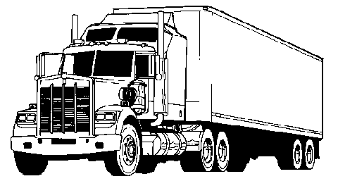

Illustrating -- Using specific examples from the text to support the claim

Authorizing -- Referring to an “expert” to support the claim

Extending -- Putting your own “spin” on terms & ideas you take from other texts
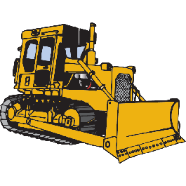

Countering -- “Pushing back” against the text in some way (e.g., disagree with it, challenge something it says, or interpret it differently)

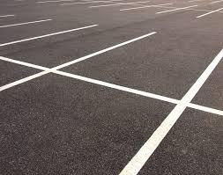

None of the above

8. Based on your reading and your responses here, what do you see as the next steps for this writer?

