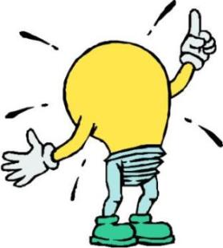
Point of Most Significance

What stands out to you from our work today? What is your big takeaway?

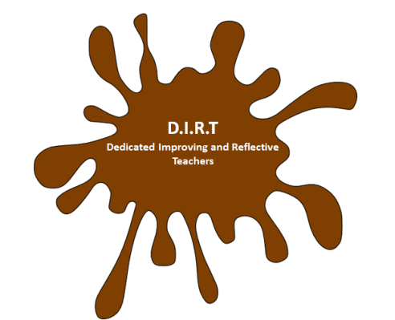
Muddiest Point

What do you need some clarification on?

