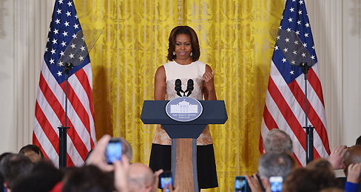


Keeping Schools Healthy

The White House sets limits on ads for unhealthy snacks and drinks in schools
First Lady Michelle Obama makes an announcement about new school wellness standards. (MANDEL NGAN—AFP/GETTY IMAGES)
Feb 25, 2014 | Adapted from an article by Denver Nicks & David Winograd for TIME, with AP reporting (9.7)

On Tuesday, the White House and the U.S. Department of Agriculture set new limits for promoting junk food and sugary drinks in schools. The rules ban advertisements for unhealthy foods on school grounds during the school day. The ad ban includes sugary drinks that account for more than 90 percent of unhealthy ads in school. An ad for regular Coca-Cola, for example, would be banned from a scoreboard at a high school football game. But, ads for Diet Coke and Dasani water, owned by the same company, would be allowed.
The new rules are part of the first lady’s “Let’s Move” campaign to fight childhood obesity. Her goal is to get kids to eat healthier—like the new rules that require healthier cafeteria food. The marketing limits come after new USDA regulations that put a limit on the calorie, fat, sugar, and sodium in most school food items. The healthier food rules are criticized by people who think the government should not control what kids eat and by some students who don't like the healthier foods.
“The idea here is simple—our classrooms should be healthy places,” First Lady Michelle Obama said in a statement. “Because when parents are working hard to teach their kids healthy habits at home, their work shouldn’t be undone by unhealthy messages at school.”
A Healthy Message
According to the USDA, companies are spending $149 million a year on marketing to kids in schools. But, the big industry giants like Coca-Cola and PepsiCo are supporting the new rules. Many have already started to advertise their own healthier products. For schools, junk food ads like a Coca-Cola scoreboard could be taken down over time—not replaced overnight. The next time the school needed to replace its scoreboard, it would have to get one with a healthier message.
“The new standards ensure that schools remain a safe place where kids can learn and where the school environment promotes healthy choices,” Agriculture Secretary Tom Vilsak said in a statement.
The new USDA plans announced today also aim to help feed hungry kids in need. They would allow the highest-poverty schools to serve breakfast and lunch to all students for free. The White House says that will help feed about 9 million kids in 22,000 schools. The rules will help guide schools on ways to create standards for foods and physical activity. They would require parents and the community to be involved in those decisions.
Good News
Obesity rates among toddlers in the U.S. have dropped greatly over the last 10 years. According to a survey done by the Centers for Disease Control (CDC), there has been a 43 percent decrease. The obesity rate for American children in the two to five-year-old age group dropped from 14 percent in 2003-2004 to just above 8 percent in 2011-12.
“This confirms that at least for kids, we can turn the tide and begin to reverse the obesity epidemic,” said CDC Director Tom Frieden.
The exact reasons for the drop in obesity are unknown. But, the CDC mentions less sugary drinks and better nutrition and physical education programs at day care centers as possible causes.
First Lady Michelle Obama responded to the CDC report saying she was “thrilled at the progress we’ve made over the last few years in obesity rates among our youngest Americans.”

