If You Teach or Write 5-Paragraph Essays--Stop It!
by Ray Salazar, May 10, 2012 at 8:55 pm

Part I: Introduction--What inspired my argumentative response?
For decades, too many high-school teachers have been instilling persuasive writing skills by teaching students the five-paragraph essay. You know it:
Introduction with three reasons
Reason #1
Reason #2
Reason #3
A summary of all three reasons
It's bad writing. It's always been bad writing. With the Common Core Standards designed to shift the way we teach students to think, read, and write, this outdated writing tradition must end. If you're teaching it--stop it. If your son, daughter, niece, or nephew (or a young person you care about) is learning it--prepare to engage with the teacher to end it.
The five-paragraph essay is rudimentary, unengaging, and useless.
If I were using five paragraphs to convince you, based on the argument above, you wouldn't need to read any farther. Instead, we should use the original argumentative form Aristotle promoted but that somehow got watered down into the ordinary structure we, unfortunately, were likely taught or may currently teach.
Aristotle became one of the godfathers of rhetoric by creating structures for persuasive writing and speaking that--if taught to young people today--would transform writing instruction and facilitate the implementation of the Common Core, proving that students--when guided appropriately--can succeed with critical thinking in the 21st century.
Part 2: Background--What preceded my argument and / or what needs to be clarified?
Teachers know that, in the '90s, state standards were developed to guide instruction. Some teachers liked them; some hated them. Each state, though, had its own. A few years ago, the National Governors Association Center for Best Practices and the Council of Chief State School Officers began work on national standards to increase consistency. These new national standards are challenging--and necessary.
According to the Common Core Web site, the "standards provide a consistent, clear understanding of what students are expected to learn, so teachers and parents know what they need to do to help them. The standards are designed to be robust and relevant to the real world, reflecting the knowledge and skills that our young people need for success in college and careers."
Besides allowing for instructional consistency among states, the states help align instruction vertically so one grade's instruction leads to the next.
The Common Core site also states that "these standards define the knowledge and skills students should have within their K-12 education careers so that they will graduate high school able to succeed in entry-level, credit-bearing academic college courses and in workforce training programs. The standards:
- are aligned with college and work expectations;
- are clear, understandable and consistent;
- include rigorous content and application of knowledge through high-order skills;
- build upon strengths and lessons of current state standards;
- are informed by other top performing countries, so that all students are prepared to succeed in our global economy and society; and
- are evidence-based."
If high-school students and teachers are to succeed with Common Core Standards, the five-paragraph essay cannot be part of instruction. Too many times, this ordinary format is the default mode for expressing thinking in English, in history, in science, in P.E., and even in math. The problem is this format doesn't encourage thoughtful persuasion. It promotes low-level summary that nobody really cares about.
Aristotle rightfully promoted five parts to effective writing and speaking. Eventually, because of low expectations, because of poor literacy training, because of convenience or some combination, these five parts became five paragraphs. And writing became boring and predictable.
Part 3: Confirmation--What supports my argument?
The thesis or argument in the traditional five-paragraph essay doesn't lend itself to debatability or originality. It's a trap that students can never escape. A few years ago, I got the chance to be an AP English reader for the College Board. Over and over, if a student used the rudimentary three-part "argument," there was no way he or she could demonstrate success in the analysis essay--even though we were all supportive readers. Students were trapped into only writing about three aspects of the text instead of starting at the top, ending at the bottom, and going through the text with a critical eye that revealed an insight to the reader.
In competitions such as history fairs, students cannot compete with the rudimentary three-part argument. When I started a Writing Center at a selective-enrollment high school a couple of jobs ago, the history teacher came to me and said she needed something to help students succeed. Over and over, she was getting arguments with blank, blank, and blank.
Together we came up with this structure for arguments, which has served me and students well:
specific topic + debatable view + significance to the audience
- Example A: The longer school day in Chicago next year does not guarantee that students will be productive in classes, reminding us that young people need to find learning meaningful.
- Example B: The longer school day in Chicago next year does guarantee more learning opportunities, resulting in increased student success.
If students want to get really fancy, they can use a subordinate phrase at the beginning to de-emphasize common beliefs:
- Example C: Despite its widespread use, the traditional five-paragraph essay does not allow students to express ideas engagingly, proving that this structure limits students' writing development.
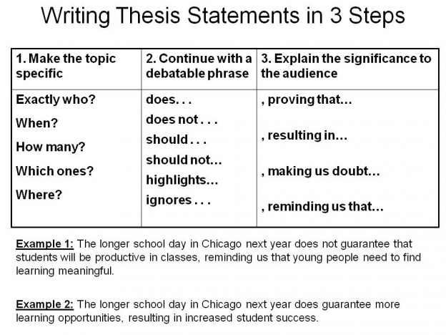
The image [at right] is the handout I use with students thanks to the conversations with my mentor Robin Bennett, a fondly remembered theater and history teacher.
Another damaging aspect of using five paragraphs is that students find it almost impossible to do anything but write in expository paragraphs. If we use Aristotle's original form instead, students are able to incorporate compare/contrast, cause/effect, definition, or analysis paragraphs as appropriate. We'll have more modes to teach; students will have more options.
Aristotle's form, however, is not a one-size-fits-all approach. This form doesn't work for science lab reports. For that, we should follow the example of the science tradition. Lab reports are not argumentative.
This form should also not be the form for a narrative essay. For that, we should follow the example of NPR This I Believe essays. While personal essays do carry a subtextual argument, they are not intended to persuade. They are written so we can experience what we have not or find solidarity through what we have.
Aristotle's form works only for persuasive essays--which need to be part of our educational system more often. We just need to make sure that we are presenting students with persuasive prompts that have more than one reasonable response.
Part 4: Refutation--What challenges my argument?
I know. I know. I'm hearing, "But how are students going to learn organization without learning the five-paragraph essay?" My response: they're not learning an organizational pattern that will help them succeed outside of your own classroom.
Effective cover letters aren't written in five-paragraph essays. We don't expect a news article to follow a five-paragraph format. Quite simply, there aren't always three reasons to prove our point.
Students need to write for a specific rhetorical context. The College Board promotes the SOAP format to help students understand guidelines and expectations:
Subject: Who or what are you writing about?
Occasion: What idea or incident is inspiring this need for persuasion? How much time to you have to write this?
Audience: Who will read this? What do they believe about the subject? Are they a supportive or skeptical audience?
Purpose: What is the job of this essay? What specifically do you want the audience to realize?
Students and teachers can use this to deconstruct prompts. Finally, the SOAP format, when combined with Aristotle's form, can help students write one or ten page essays effectively. The five paragraph essay limits students into about 1 1/2 pages.
Part 5: Conclusion--What are the benefits of accepting my argument?
Aristotle called the last part of the persuasive event the epilogue. Unlike the five-paragraph essay that begins with "As you can see . . ." and leaves the reader thinking, "Why are you telling me what you told me a couple minutes ago? I'm not stupid," Aristotle, in The Rhetoric, tells us a good writer should do this in the conclusion: "make the audience well-disposed towards ourselves and ill-disposed to our opponent." One way to achieve this is to explain the benefits if the audience accepts our view. It's a good opportunity for students to make inferences or predictions.
If teachers and students move away from the rudimentary, unengaging, and useless five-paragraph format, students will be able to think for themselves and understand that writing can really challenge people's views. Students will create persuasive essays that incorporate information in un-identical ways to everyone else. Furthermore, rhetorical limits won't be obstacles; they'll become guidelines for success.
Finally, students will learn that their persuasive abilities, when used responsibly, will have value outside of the 46 minutes they were given to write.

http://www.chicagonow.com/white-rhino/2012/05/if-you-teach-or-write-5-paragraph-essays-stop-it/

