Australia news /The Guardian Winner of the Pulitzer Prize in 2014
Monday 6 October 2014 22.25 EDT / Last modified Monday 6 October 201422.27 EDT
Excerpt from an opinion piece, adapted for classroom use (10.2)
Full article available at http://www.theguardian.com/commentisfree/2014/oct/07/-sp-if-great-architecture-belongs-to-humanity-do-we-have-a-responsibility-to-save-it-in-war-times

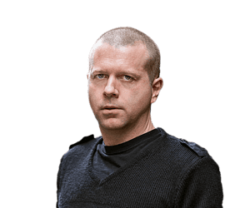

If great architecture belongs to humanity, do we have a responsibility to save it in wartimes?
Jeff Sparrow

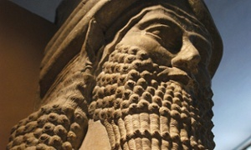
A statue is on display in the Assyrian hall of Baghdad’s National Museum in 2005. Photograph: Charles Onians/AFP/Getty
Contact author
@Jeff_Sparrow

The lands of Syria and Iraq gave rise to some the oldest societies we know: the Sumerians, the Akkadians, the Babylonians, the Assyrians, the Parthians, the Romans and many others. Traces of these peoples remain in important archeological sites.
And now they’re being destroyed.
Satellite imagery shows the cultural effects of Syria’s civil war. “The buildings of Aleppo, one of the oldest continuously inhabited cities in the world, has suffered extensive damage,” explained Archaeology magazine. “The ancient city of Bosra, the ancient site of Palmyra, the ancient villages of Northern Syria, and the castles Crac des Chevaliers and Qal’at Salah El-Din have all been damaged by mortar impacts and military activity.”
So too in Iraq.
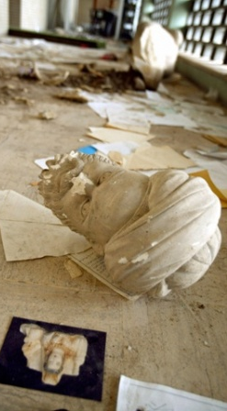
Sometimes, the destruction is accidental (if that term means anything in wartime). Sometimes it’s deliberate, with the Islamic State leveling ancient religious sites.
After looters attacked Baghdad’s National Museum in 2003, Francis Deblauwe started the (now defunct) Iraq and Archaeology site. He wrote:
War in this cradle of civilization … inevitably takes its toll on the archaeological heritage as well. After all, this fertile flood plain and surrounding mountains gave birth to agriculture, to writing, to cities, to laws, to the 24 hours in a day, and many more things we take for granted.
***
Iraq takes its name from Uruk. Uruk was the ancient city said to have been ruled by Gilgamesh, sometime between 2,500 and 2,700 BC.
A beheaded looted sculpture in Iraq's archeological museum in Baghdad. Photograph: Patrick Baz/AFP/Getty
In the epic poem that bears his name, Gilgamesh leaves Uruk. He had built Uruk. But he was grieving the death of his friend. After many adventures, he accepts that only the gods endure forever. He then returns to Uruk with new appreciation. A city is a human achievement. It offers the only immortality humans can expect.
David Ferry’s translation describes Uruk as follows:
The outer wall
shines in the sun like brightest copper; the inner
wall is beyond the imagining of kings.
Study the brickwork, study the fortification;
climb the great ancient staircase to the terrace;
study how it is made…
Uruk’s ruins were rediscovered in the 19th century, 250kms south of Baghdad. That means we can study the brickwork, the fortifications and the outer walls Gilgamesh once saw. When we do, we are met with the same questions about eternity he pondered 4,500 years ago.
The ancient stones show the persistence of our culture. Preserving culture, as the poem suggests, is our only comfort for the fact that we all will die someday.
That’s why, in The Seven Lamps of Architecture, the great Victorian art critic John Ruskin argues that we have a responsibility to such artifacts. He warns:
They are not ours. They belong partly to those who built them, and partly to all the generations of mankind who are to follow us. The dead have still their right in them: that which they labored for, the praise of achievement or the expression of religious feeling, or whatsoever else it might be which in those buildings they intended to be permanent, we have no right to obliterate.
Great architecture, Ruskin says, belongs to humanity as a whole. It does not belong to “those mobs who do violence to it”. It’s an argument that surely applies to the relics of ancient Mesopotamia, caught between Islamic State fighters and US strike bombers.
But can we – or, rather, should we – protect the rights of the dead when we cannot guarantee the rights of the living?
***
Nearly 200,000 people have already died in Syria’s civil war. Estimates of deaths from the 2003 Iraq invasion vary from several hundred thousand to over a million. In the midst of unimaginable blood and suffering, is it wrong to care about the walls of Uruk?
“I wish to be absolutely clear,” writes Deblauwe, “no epic Sumerian cuneiform tablet, majestic Neo-Assyrian lamassu sculpture or any other Mesopotamian artifact is worth a human life, be it Iraqi, American, British or other.”
The bluntness of that statement, from a man who deeply cares about Sumerian cuneiform tablets, contrasts with Ruskin’s comments. He champions the past over the flesh and blood of today’s people. He privileges a bygone world over the one in which we actually live.
There’s a long, disgraceful tradition of revering the ancient world while belittling anyone with the nerve to live in those cities today. When cultural treasures were seized from “lesser” populations it was often on the basis that the ignorant locals couldn’t appreciate the stuff’s value. That’s how major British museums built their collections, from the Elgin Marbles to the bones of Aboriginal people.
Yet it’s worth thinking about the need for such actions.

