Healthy Kids Today -Prevent Cancer Tomorrow
Adapted from http://www.superkidsnutrition.com/nutrition-articles/healthy-kids-today-prevent-cancer-tomorrow/
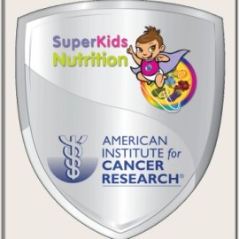
What if you could protect your yourself from developing cancer later in life? YOU CAN — starting with your next meal!
Learning healthy habits is as important as learning to cross the street safely. The Healthy Kids Today — Prevent Cancer Tomorrow Campaign will show you how to make simple changes every day that add up to lower cancer risk for you whole family.
The American Institute for Cancer Research shows that if we all ate smarter, moved more and stayed lean, about 1/3 of the cancers that occur in the U.S. could be avoided.

