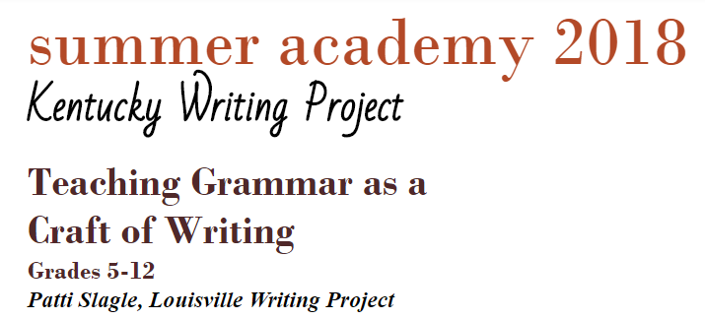
TOPICS INCLUDE
- Making grammar relevant for students
- Exploring grammar applications in the real
world

- Approaching grammar as a skill rather than
as content

- Exploring the connection between grammar and reading comprehension

- Addressing grammar as a writer
- Exploring the role of grammar in determining an author’s purpose
- Discovering the function of grammar in communicating with an audience
- Integrating student/classroom reading with grammar instruction
- Using inquiry instruction to foster grammar acquisition
- Unlocking the intimidating mystery of grammar and its applications in writing
12 hours of professional development credit!

Dates: June 25 & 26 (Mon. & Tues.)
Time: 8:30 – 3:30 (1 hr. for lunch)
Location: Peak’s Mill Elementary, 100 Peak’s Mill Rd., Frankfort, KY

12 hours of professional development credit!

Registration:

2018 KENTUCKY WRITING PROJECT SUMMER ACADEMY

TEACHING GRAMMAR AS A CRAFT OF WRITING
Frankfort, KY

Early-Bird Registration, $125 by June 1
Regular Registration: $175 after June 1

Name_____________________________________E-Mail________________________________
Home Address_______________________________________ Phone_______________________
________________________________________________________________________________
(City) (State) (Zip)
County _________________________________________________________________________
Grade Levels _____________ Subjects Taught __________________________________________
School _______________________________________ Principal __________________________
School Address___________________________________________ Phone___________________
________________________________________________________________________________
(City) (State) (Zip)

Payment information:
_____ Check enclosed for _______ ($125 if paid by June 1; $175 after June 1.)
_____ Purchase Order Number _____________________ for _______ ($125 if sent by June 1; $175 after June 1.)
_____ Please bill us before June 30. _____ Please bill us after July 1.
Please send payments to Jean Wolph, LWP Director, CEHD 105, 1905 S. 1st Street, University of Louisville, Louisville, KY 40292
Payment & Registration Questions:
Linda Satterlee-McFadin, lksatt01@louisville.edu, 502-852-4544.

Program Questions: Patti Slagle, slagerman@twc.com

