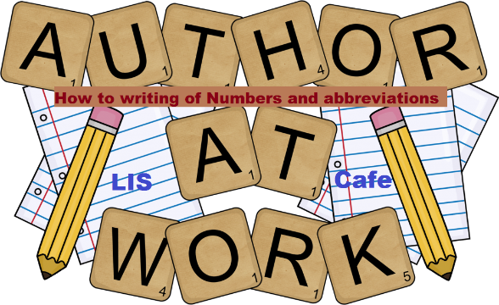
Summer 2018 Professional Development
Kentucky Writing Project

Components of a Strong Writing Program, Grades 3-6

June 25-26, 2018 / Paducah, KY
July 12-13, 2018 / Frankfort, KY
Come either day or both days! OR Call about scheduling these workshops at your school this summer!

Day 1:
  - Daily Writing to Build Fluency and Stamina in ELA
  - Connecting Reading and Writing
  - Writing for Real Audiences and Purposes

Day 2:
  - Daily Writing to Build Fluency and Stamina in the Content Areas
  - Opportunities to Write in Science and Social Studies
  - Writing for Assessment

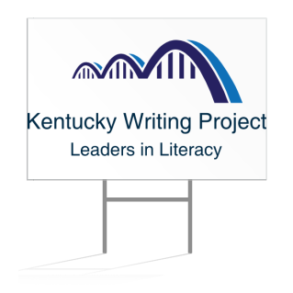

KENTUCKY WRITING PROJECT SUMMER ACADEMY
Components of a Strong Writing Program, GRADES 3-6

Participant Name __________________________________________________________
Grade level(s) of educator who will participate: 3__ 4__ 5__ 6__ Other___
School or District ____________________________ Supt. or Principal ________________________
Billing Address___________________________________________ Phone___________________
________________________________________________________________________________
(City) (State) (Zip)
Billing Contact Person__________________________E-Mail_______________________________
Location: Frankfort ___ July 12-13 Paducah ____ June 25-26
____Two-Day Option: Early bird $175; after June 1, $225
____One-day Option, Day 1 only: Early bird $105; after June 1, $150
____One-day Option, Day 2 only: Early bird $105; after June 1, $150
Payment information:
_____ Check enclosed for _______
_____ Purchase Order: Number _____________________ for _______ _____
_____ Please bill us before June 30. _____ Please bill us after July 1.
Please send payments to:
Jean Wolph, KWP Director, CEHD 105, 1905 S. 1st Street, University of Louisville, Louisville, KY 40292.

Payment & Registration Questions: Linda Satterlee-McFadin, lksatt01@louisville.edu, 502-852-4544.
Program Questions: Stephanie Wilson, Stephanie.wilson@franklin.kyschools.us; Harold Woodall, Harold.woodall@rockcastle.kyschools.us, Debbie Bell, dbell@murraystate.edu

