NYC public school swaps chicken nuggets for tofu, becomes first all-vegetarian cafeteria
Wednesday May 1, 2013 7:29 AM
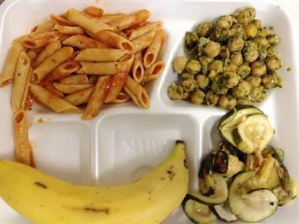
Lalita Kovvuri / NYC Department of Education
Vegetarian lunch is served: A vegetarian meal at P.S. 244 in Flushing, Queens.
By Elizabeth Chuck, Staff Writer, NBC News
Braised black beans and plantains. Tofu roasted in Asian sesame sauce. Falafel and cucumber salad. These aren't menu items from a high-end restaurant; they're lunchtime grub for students at a Flushing, Queens, public school's all-vegetarian cafeteria, the first in New York City to nix meat and believed to be one of the first public school in the nation to serve only vegetarian fare.
P.S. 244 in Flushing, the Active Learning Elementary School, which opened in 2008, gradually started offering vegetarian meals more and more days a week, reducing the days per week they served traditional cafeteria food like chicken nuggets, said P.S. 244 principal and co-founder Robert Groff.
"The founding of our school was based on health and nutrition and teaching kids how to make healthy choices in the belief that they would be more successful academically and in their life," Groff said. "But then we started to watch the kids. One, what they would bring in to school, and two, what they would gravitate towards in the cafeteria."
Administrators noticed a higher number of vegetarian meals in the cafeteria, he said, partially because of the school's population: P.S. 244 is about 70 percent Asian and Indian. The switch to meatless — which the school did in partnership with nonprofit organization New York Coalition for Healthy School Food — was seamless.
Follow @NBCNewsUS
"Our head cook is also a vegetarian herself and a parent in the school," Groff said.
P.S. 244, which serves 400 students from pre-kindergarten through grade three, went all-vegetarian in January, but was just publicly recognized by the New York city schools chancellor, Dennis Walcott, during a visit on Tuesday.
“I am proud of the students and staff for trailblazing this extraordinary path,” Walcott said in a news release.
Other items on the menu at P.S. 244 include tofu vegetable wraps, vegetarian chili served with brown rice, and black bean and cheddar quesadillas served with salsa and red roasted potatoes. Each meal has the same amount of mandatory USDA protein requirements as their meat counterparts have in other public schools.
Breakfast is also served, and that's vegetarian, too. Students start out their day with bagels and cream cheese, whole-grain banana bread, egg and cheese roll-ups, to name a few of the offerings from this month.
"We know that when students eat a healthy diet, they're able to focus better. Their immune systems are stronger, so they're sick less, and then they're in school more and they're able to focus and concentrate better, and therefore learn better. There's research about that," said Amie Hamlin, the executive director of New York Coalition for Healthy School Food, which has worked with P.S. 244 for several years.
Not all "typical" Department of Education meals have been removed from the cafeteria: Pizza Fridays are still on the menu, just without the pepperoni. Groff said most parents have greeted the changes warmly, and for those who haven't, he encourages them to send their children into school with their own lunches.
"That, alone, providing the options for the kids makes the difference," he said.
The move to all-vegetarian has been in parallel with New York Mayor Michael Bloomberg's citywide health efforts.
"We've been watching how the mayor has been responding to something like sugary beverages or the smoking ban, and that was an opportunity for us, because we could see the direction the city is moving," Groff said. "We could move along with it to create the healthiest options for our kids."

Tip of the Day: A New Food Pyramid
June 17th, 2010 | Published in Being Green, Rose Thornton posts | 3099 Comments
Does anyone know if Jamie Oliver’s Food Revolution will be launching a second season? I know season one left me with a lot of (ahem) food for thought. One of the most surprising things I learned was how school districts defined “healthy food” and “vegetables” for their school lunch programs. And I’ll say this without any reserve: if our EDUCATION system qualifies french fries as a suitable vegetable, we need to send the entire system back to school.
Here I’ve included two food pyramids. First is the food pyramid that I grew up with.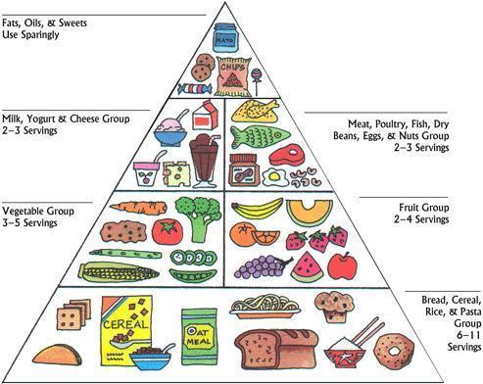
The second is the food pyramid designed by Harvard.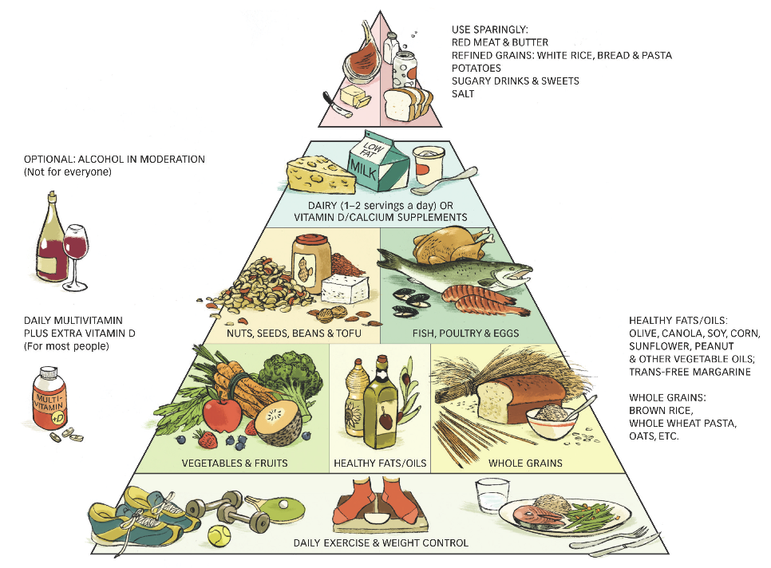
Take just a few minutes to acknowledge the differences. This week’s tip of the day is to reframe your idea of the food pyramid around this second option share it with your kids to start a food revolution at home.
Rose Thornton is the co-creator and producer of Mission: Sustainable

It's not just fast food making U.S. kids obese, study says
By Los Angeles Times, adapted by Newsela staff
01.24.14 midnight
Imagine for a moment that all of the nation’s fast-food establishments — all the drive-thru windows, the beckoning dollar deals and wafting odor of French fries — were to vanish overnight. Would the number of our kids who carry an unhealthy amount of extra weight plummet?
The answer is very likely no, says a study published this week in the American Journal of Clinical Nutrition. You can shut off the supply of 24-ounce fountain drinks, bacon cheeseburgers, fried chicken and stuffed tacos.
But the children who frequently eat at fast-food restaurants will go home and do what they generally do when not eating at a fast-food restaurant: They’ll snarf cookies and chips, chug sugar-sweetened soda from a bottle, and heat up frozen pizzas.
Researchers from the University of North Carolina led by nutrition professor Barry Popkin studied the issue. They found that children who frequent fast-food restaurants tend to eat food that would probably make many of them overweight or obese anyway. They do this even when they are not eating at those restaurants.
The authors of the latest research combed through a national database of Americans’ health and nutrition behaviors. They grouped 4,466 American kids — from ages 2 to 18 — according to what they ate when they were not eating food purchased at a fast-food restaurant.

What They Eat, Not Where, Important
Participants were designated “Western diet” consumers if their consumption from non-fast-food sources was relatively high in saturated fats and added sugars. Others were classified as following a “prudent diet.” They ate more fruits and vegetables, leaner proteins and less added sugar and saturated fat.
After doing so, the authors went back to the children’s detailed food consumption record. They categorized some of the children as nonconsumers of fast food. Those children had food tracking records that indicated no calories consumed from a restaurant or eating establishment without servers. Others were called low consumers. Their food tracking records indicated that no more than 30 percent of their calories came from such an establishment. The last group was called high consumers. More than 30 percent of the calories consumed came from a fast-food restaurant.
The result: Those who followed the Western dietary pattern when not dining at fast-food restaurants had the highest rates of being overweight or obese. This was true even for those who were considered “nonconsumers” of fast food. Those who followed a “prudent diet” when not dining on fast food were significantly less likely to be overweight or obese. This was the case even for those who were considered high consumers of fast food.
On average, low consumers of fast food were 1.5 times as likely to follow a Western diet pattern of consumption than people who were considered nonconsumers of fast food. High consumers of fast food were 2.2 times as likely to do so.
“Our findings suggest that the location where foods are obtained may not be as important as the nutritional quality of the foods consumed,” the authors wrote in Thursday’s study. They also suggest that “the effect of public health efforts targeted at fast-food restaurants may also be overestimated." Those efforts may be "necessary but not sufficient to reduce child obesity if the remainder of the diet is not addressed.”
The study was sponsored by the Robert Wood Johnson Foundation. The authors — Jennifer M. Poti, Kiyah J. Duffy and Popkin — declared they had no financial conflicts of interest with respect to the article.

June 2, 2011

Nutrition Plate Unveiled, Replacing Food Pyramid

By WILLIAM NEUMAN
The first lady, Michelle Obama, on Thursday relegated the government’s well-known food pyramid to the sands of history, unveiling a new, simpler image of a plate divided into basic food groups.
The new design, called MyPlate, was conceived as a crucial part of Mrs. Obama’s campaign against obesity, designed to remind consumers about the basics of a healthful diet.
The plate is split into four sections, for fruit, vegetables, grains and protein. A smaller circle sits beside it for dairy products.
Mrs. Obama, Agriculture Secretary Tom Vilsack and Dr. Regina M. Benjamin, the surgeon general, unveiled the new healthful eating icon at a news conference in Washington.
“This is a quick, simple reminder for all of us to be more mindful of the foods that we’re eating,” Mrs. Obama said. “We’re all bombarded with so many dietary messages that it’s hard to find time to sort through all this information, but we do have time to take a look at our kids’ plates.”
If the filled plate looks like the symbol, with lots of fruits and vegetables, she said, “then we’re good, it’s as simple as that.”
The Agriculture Department has created a Web site, ChooseMyPlate.com, that elaborates on the guidance reflected in the plate’s design. It includes tip sheets with recommendations like eating fish twice a week and avoiding high-fat, salty foods like salami and bologna.
Officials said they planned to use the plate in a campaign to communicate essential dietary guidelines to consumers, emphasizing one message at a time for the best effect.
The first part of the campaign will encourage people to make half their plate fruit and vegetables. Later phases will urge consumers to avoid oversize portions, enjoy their food but eat less of it and drink water instead of sugary drinks.
Nutritionists often criticized the food pyramid, which was first advanced in 1992, for being misleading or hard to understand. Some gave the plate cautious praise on Thursday.
“It’s better than the pyramid, but that’s not saying a lot,” said Marion Nestle, a professor of nutrition at New York University.
Dr. Nestle praised the plate for being generally easy to understand, but she said that labeling a large section of the plate “protein” was confusing and unnecessary, because grains and dairy products also are important sources of protein and most Americans get far more protein than they need.
But she said the emphasis on fruits and vegetables was a significant step.
“Americans aren’t used to eating this way, so this is a big change,” Dr. Nestle said.
The plate was created by the Agriculture Department with advice from the first lady’s anti-obesity team and federal health officials. The Agriculture Department said that it had conducted focus groups with about 4,500 people, including children, as it developed the plate.
The project, with the Web site and related educational materials, cost about $2 million. That money will also help pay for an educational campaign about the plate over the next year, officials said.
February 25, 2010

‘Yes’ to Pop-Tarts! Panel Approves Bake-Sale Rules

By JENNIFER MEDINA
By the time the Panel for Educational Policy was ready to vote on bake sales during its monthly meeting on Wednesday night, it was after 11:30. By then, just one mother, Elizabeth Puccini, was waiting to speak out against the new policy, which bans most bake sales but allows students to sell premade items including Pop-Tarts and Doritos.
“The idea that the D.O.E. can control the calories a child consumes at a fund-raising event is specious at best,” she said, referring to the Department of Education. “What’s to prevent a child from buying two or three bags of the permitted Doritos or Frito-Lay chips? As much as the D.O.E. might like to control what our children eat, it’s impossible to regulate how much they eat unless a monitor is stationed at every school fund-raising event.”
Ms. Puccini, whose children attend the Children’s Workshop School in the East Village, said the regulation appeared to be a “blatant attempt by food companies such as Pepsi-Cola and Kellogg’s to reap enormous profits at the expense of our children” — an opinion shared by many of the more than 200 readers who commented on an In the Schools item on City Room this week outlining the policy. Ms. Puccini added that the school should focus on eliminating the high-fructose corn syrup in many cafeteria items.
Kathleen Grimm, the deputy chancellor who oversees the regulation, told members of the panel that the permitted snacks were not “necessarily foods we recommend that students eat.”
“We think an apple is the best snack,” she said, generating chuckles from panel members.
With the clock nearing midnight, there was little discussion. The policy was approved unanimously.

Schools find stricter federal nutrition standards hard to swallow

By Joe Robertson, The Kansas City Star
May 14, 2014
Grade level: 10
Second-graders Jaloni Smith (left) and Mira Stuckey eat lunch at Dobbs Elementary School in Kansas City, Mo. USDA regulations on nurtition in school lunches are causing angst among cafeteria nutritionists. Photo: Kansas City Star/MCT
KANSAS CITY, Mo. — Hickman Mills school nutritionist Leah Schmidt has always loved solving that puzzle of serving up healthy meals that nose-wrinkling children actually will eat.
The regular post-lunch parade of Dobbs Elementary children by the trash cans Monday showed that the school’s food team had mostly pulled off a successful meal.
Here and there, some whole servings of apple slices got dumped, but otherwise empty trays and empty milk cartons filled the bins.
But the puzzle may soon become too hard, Schmidt fears.
The School Nutrition Association is calling on Congress and the U.S. Department of Agriculture to ease up on the next round of federal healthy food requirements, due July 1. The goals have been rising steeply over the last two years.
Schmidt is the current national president of the nutrition association.
The nutritionists are worried about three regulations. One would require all grain servings to be rich in whole grains — or more than 50 percent whole-grain — affecting such items as pastas, bread, rolls and pizza crusts. The current rule requires half the grain servings to be rich in whole grains.
Another rule would make it so children must pick up a fruit or vegetable with each meal, rather than just expecting servers to strongly encourage it. Schools fear it will lead to food waste.
The USDA also is phasing in steep reductions in the allowable amounts of sodium, which would become a problem particularly with the levels expected by 2017, Schmidt said.
“One deli turkey sandwich with cheese and mustard would use up most of the sodium for the week,” she said.
Schools already are feeling some strain, the nutrition association reported. Since the new standards were first implemented in 2012, the number of children participating in lunch and breakfast programs has fallen by 1.2 million, from 31 million to less than 30 million.
“It used to be fun playing with things, letting kids pick things,” Schmidt said of menu planning. “But now when you get a menu down, you don’t change it.”
As things are, schools already have responded to weekly limits on calories, sodium and fat while meeting rising expectations on nutrients, grains and meats — all variable according to the ages of students, including limits within limits.
The calories within the overall limit can’t be more than 30 percent fat or 10 percent saturated fat.
Dobbs fifth-grader Cree Crook said she thinks her school’s lunch team has done fairly well satisfying her and her classmates. The whole-grain movement has taken regular macaroni and cheese out of the mix. (Whole-grain pasta just doesn’t work with that kid favorite, Schmidt said.) But that’s OK, said Cree.
“We have the Santa Fe Mac,” she said, meaning the whole-grain pasta and cheese dish with red sauce. “It’s good, and it comes with a whole-wheat roll. The wheat roll is very healthy for you.”
Cree said she thinks children are getting the message. She knows to get tomatoes and lettuce in her taco salad. She’s learned to like green beans.
The USDA acknowledges that schools have come a long way toward providing healthy meals. More than 90 percent of schools are meeting the standards.
In the Shawnee Mission School District, the food services manager, Nancy Coughenour, said nutritionists and students have mostly adapted to the healthier demands.
“You have to mess with it,” she said, meaning coming up with scratch recipes or working with vendors.
The district’s regular chocolate cake dessert has made the transition to whole-grain flour, she said. Going to whole-grain soft tortillas was a tricky move that seems to have gone well.
Coughenour said elementary school programs that give pupils opportunities to try new vegetables and fruits in classroom settings have helped, but she agrees that the next level of demands may be pushing too far, particularly with the sodium limits.
The 2017 target — 935 milligrams total in an elementary school lunch and 1,080 milligrams in a high school lunch — looks to be too high of a standard for food manufacturers, Coughenour said. Some student favorites may not survive.
“You have to rely on manufacturers,” she said. “Chicken nuggets, pizza, ketchup, mustard — I don’t know what we’ll do with those.”
Janey Thornton, a USDA undersecretary, acknowledged the food industry isn’t ready to meet the coming sodium standard, but she encouraged frustrated school lunch directors to “worry about today first before we imagine the worst down the road.”
Thornton, a former school nutrition director, says problems will lessen as the food industry creates healthier products. “I’ll bet that five or seven years down the road, we’ll see kids eating healthy food and we’ll see acceptance,” she said.
She said the government in particular is working with the food industry to develop better pastas.
The USDA has shown some flexibility already. In 2012, the department scrapped maximums on proteins and grains after students complained they were hungry.
Statewide, Missouri also has seen a dip in participation in school lunch and breakfast programs, down 5 percent in the 2012-2013 school year, said Karen Wooton, the state coordinator of food and nutrition services.
The USDA’s demanding standards “have good intentions,” Wooton said. “But I think more time would help for getting better compliance. There are not enough products yet. More time would be good for the industry.”
Some nutrition advocates cautioned against relaxing the new rules.
Margo Wootan, a nutrition lobbyist for the Center for Science in the Public Interest who has pushed for healthier meals, says relaxing those standards could gut the program. “You can’t call a meal a meal without a fruit or vegetable,” she said.
Republicans who have complained of government overreach say they may intervene. U.S. Rep. Robert Aderholt of Alabama, the chairman of the committee that oversees the USDA’s budget, has said school districts need a “pause” while problems are worked out.
Aderholt’s panel is expected to release a new spending bill this month that might propose changes. Republicans also are considering the next five-year renewal of the school nutrition policy, due in 2015.
Sam Kass, a senior policy adviser for nutrition at the White House, said last month that there have been “tremendous gains” in school foods. He said he finds efforts to undermine that disappointing: “First and foremost, the key is not going back.”
Cree’s not going back. Her parents are on board, she said.
“My mom and dad want me to have four vegetables and fruits (every day).”
The school nutritionists are not going back either, Schmidt said. Of course they will push for healthier meals, she said. “It’s in our DNA.”
But as for the USDA standards, she said, “I hope they’ll be realistic about it.”

First lady decries plan to lower school lunch nutrition standards
By Kathleen Hennessey, McClatchy-Tribune
June 03, 2014
Grade level: 12
First lady Michelle Obama speaks to school leaders and experts about school nutrition, in the Eisenhower Executive Office Building on the White House complex in Washington. A House committee has endorsed a GOP plan to allow some schools to opt out of healthier school meal standards. Photo: AP Photo/Pablo Martinez Monsivais, File
WASHINGTON — After steering clear of most messy legislative battles, first lady Michelle Obama on Tuesday publicly took on lawmakers, food companies and lunch ladies who say the school lunch law she championed nearly four years ago is leading kids to brown bag it.
The attempt to scale back new nutrition standards for the federal school lunch program is unacceptable, Obama declared at a meeting with school nutrition officials that launched her public campaign to defend the law. She blasted lawmakers for playing “politics with our kids’ health” and suggested they were trying to “roll back everything we have worked for.”
“It’s unacceptable to me not just as first lady, but also as a mother,” she said.
The unusually confrontational remarks were a departure for a first lady who has largely sought to work with the food industry and around Congress in her campaign against childhood obesity. As the nation’s best-known healthy-eating advocate, Obama has typically emphasized partnerships and pledges with the makers of gummy fruit snacks and sweetened cereals, aiming for incremental changes in their products and increased marketing of healthier options.
Since lobbying on behalf of the Healthy Hunger-Free Kids Act of 2010, which set new standards for school food, Obama has rarely waded into legislative or regulatory debates. The law set guidelines for the amount of sodium in school lunches and breakfasts and targets for more whole grains and fresh fruit.
But the law is being challenged in Congress by the School Nutrition Association, a coalition of school officials and the food companies that sell mini-pizzas, yogurt, pastas and chicken nuggets to schools. Its industry members include Pizza Hut, Coca-Cola, Chobani Greek yogurt and Tyson Food Service, according to the group’s website.
The group supported the law in 2010, but its leaders now say the regulations it spawned are too rigid.
House Republicans have backed the group’s efforts. The House Appropriations Committee is to vote Thursday on a provision that would allow school districts that have been operating at a loss to seek a one-year waiver from the nutrition guidelines. The measure is expected to win approval in the House.
The waiver is aimed at schools that have seen resources slide as more paying students are opting out of school lunches and bringing their own food. Some districts say they have had trouble finding affordable products that meet the nutrition standards; meanwhile, they say, they have watched students throw away large amounts of the healthy food that land on their trays.
“These new federal regulations should not drive local school nutrition programs underwater. This temporary one-year waiver simply throws them a lifeline,” said Brian Rell, a spokesman for Republican Rep. Robert B. Aderholt of Alabama, chairman of the Appropriations Committee’s agriculture subcommittee, which approved the provision on a voice vote last week.
Supporters of the waiver described it as a modest attempt to add flexibility to the program and said the first lady’s response seemed out of proportion.
But the White House has appeared eager to play offense to protect a key piece of the first lady’s legacy. White House officials helped with a letter by former presidents of the School Nutrition Association opposing the waiver plan.
The association is also seeking other changes to the law, including scrapping a requirement that foods be 100 percent whole-grain by July 2014 and sticking with the current 50 percent target; holding to the newly enacted standard for sodium rather than a lower target scheduled to go into effect in a few years; and eliminating the requirement that students take a fruit or vegetable, regardless of whether they plan to eat it.
The association “does not want to gut the nutrition standards — we support many of the requirements. Our request for flexibility under the new standards does not come from industry or politics; it comes from thousands of school cafeteria professionals who have shown how these overly prescriptive regulations are hindering their effort to get students to eat healthy school meals,” said President Leah Schmidt, in a response to the first lady’s event.
The White House argues that the U.S. Department of Agriculture (USDA), which administers the program, has been flexible. The USDA already delayed a whole-grain provision for pasta, heeding complaints that some such pastas were unpopular and could be hard to find. Officials argued against having lawmakers determine what is nutritious, noting that lawmakers have bent to food industry complaints in the past, such as an effort in 2011 to classify pizza with tomato sauce as a vegetable.
“What we’re not going to do is put politics and interests ahead of what’s good for our kids and allow politicians to set nutrition standards,” said Sam Kass, director of the first lady’s anti-obesity campaign and the White House chef. Kass said the first lady’s office hoped to amplify the voices of those school officials who think the guidelines are helping kids eat healthier diets. The USDA estimates that 90 percent of schools are in compliance.
On Tuesday, David Binkle, director of food services for the Los Angeles Unified School District, joined the first lady for the event. Binkle noted that he was a member of the School Nutrition Association, but said its “hard line” on the law did not reflect his views. Binkle said he had not had trouble procuring food that meets the federal guidelines or stricter local nutrition standards and noted that the “plate waste” critics point to was a problem before the 2010 law.
“In fact, we don’t serve the typical corn dog and chicken nuggets,” he said. “We don’t even have pizza on the menu.”

