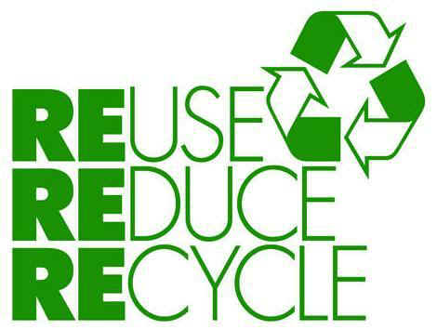

Should we recycle?

First I thought….

Then I learned….

Now I think…

