Be sure to check that the cover sheet on this prompt packet matches the one you read about yesterday.
Please fill out any missing identifying information on this cover sheet in PRINT (not cursive).

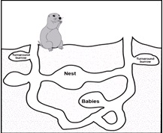

Prompt: B

Discipline and Learning

Student first name: Student last name:

Teacher name: Class period:

Grade level:
8th 9th 10th

PROMPT FOR WRITING

B. Discipline and Learning

School discipline is in the news because students who break simple rules are sometimes punished in the same ways as students who commit crimes at school. What discipline policy would you recommend to your School Board to make sure that all students have a chance to learn? Why?

Write an argument. Use ideas and evidence from the reading packet to support your argument. Use what you have learned about citing and quoting sources in your writing

The audience for your argument is the President of you School Board.

DIRECTIONS
- Take five minutes to review your reading packet, notes and planning page from Day 1.
- Use the space on the next page if you want to plan and organize before you write.
- Begin writing your argument on page 3. Use as much space as you need to complete your argument.

PLANNING YOUR WRITING (optional)

START WRITING HERE

IF YOU NEED ADDITIONAL SPACE TO WRITE, get lined paper from your class and staple to this packet when you’re done writing.

