Diabetes Researchers Report New Steps Towards the First Artificial Pancreas
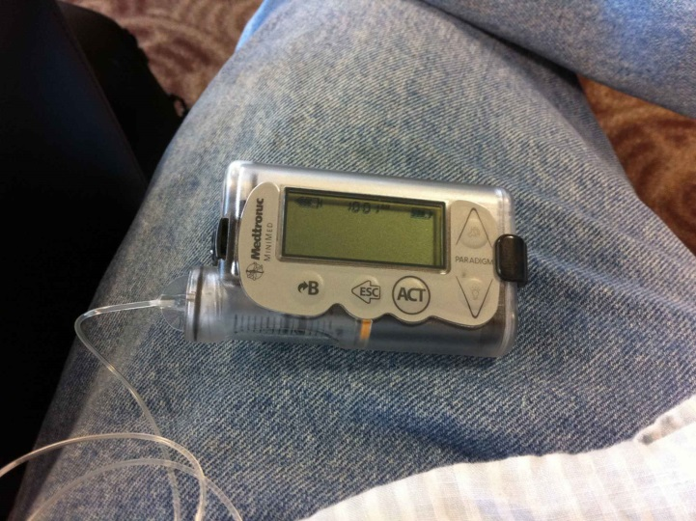
By Rebecca Boyle
Posted June 27, 2011 (Used with permission and adapted for classroom use, 9.9)
Medical researchers are making progress toward developing an artificial pancreas. It would take the place of insulin injections and finger pricks for patients with diabetes. It would mimic the functions of a healthy pancreas. In other words, it would deliver insulin and monitor blood sugar using computer technology. Endocrinologists [doctors who study and treat the endocrine system, which produces hormones] have presented their findings to the American Diabetes Association.
Insulin Pump (cogdogblog via Flickr) 1
Mayo Clinic researchers are making an artificial pancreas that can adjust the amount of hormones it delivers. This device can respond to minor physical activities. Why is that important? Physical activity can affect blood sugar levels. Their system includes a glucose monitor, automatic insulin pump, activity monitors that attach to the body, and a central computer. The computer uses an insulin-delivery algorithm [a set of rules for solving a problem] to determine how much of the hormone to release.
A team led by Yogish Kudva at Mayo attached the devices to diabetics [people who have diabetes]. They tracked their blood sugars while they moved around after eating. They found that even small movements had a big effect on blood sugar levels. These movements brought their sugar levels almost to normal. But insulin pumps and glucose monitors don't account for those changes. The new process could help diabetics better manage their insulin intake, the Mayo researchers said.
In another study, researchers at Yale University tested an artificial pancreas that measures and regulates glucose throughout the night. They found it worked better than a traditional insulin pump. The monitor sent signals to a laptop. The computer calculated how much insulin to release. The system is simple enough that it could eventually be added to a wearable device, according to the researchers.
The device is already approved in Europe.

Copyright © 2015 Popular Science. A Bonnier Corporation Company. All rights reserved. Reproduction in whole or in part without permission is prohibited.

