Be sure to check that the cover sheet on this prompt packet matches the one you read about yesterday.
Please fill out any missing identifying information on this cover sheet in PRINT (not cursive).
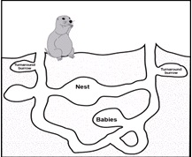
A
Prompt:

Concussions: A Game Changer?

Student first name: Student last name:

Teacher name: Class period:

Grade level:
8th 9th 10th

PROMPT FOR WRITING

A. Concussions: A Game Changer?

Hard hits in youth sports can result in concussions that are sometimes temporary and always serious. What do you think adults in charge of youth sports should do about the risk of concussions? Why?

Write an argument. Use ideas and evidence from the reading packet to support your argument. Use what you have learned about citing and quoting sources in your writing

The audience for your argument is a coach or principal in your school community.

DIRECTIONS
- Take five minutes to review your reading packet, notes and planning page from Day 1.
- Use the space on the next page if you want to plan and organize before you write.
- Begin writing your argument on page 3. Use as much space as you need to complete your argument.

PLANNING YOUR WRITING (optional)

START WRITING HERE

IF YOU NEED ADDITIONAL SPACE TO WRITE, get lined paper from your class and staple to this packet when you’re done writing.

