Are

rules important?

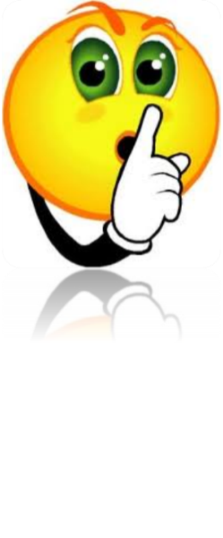

By _____________________

**First, I thought…**

☺ rules are important.

😐 that I am not sure if

rules are important.

☹ rules are not important.

**Then, I learned…**

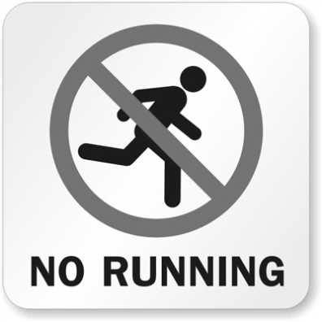

**Then, I learned…**

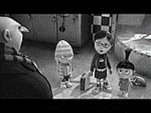

**Then, I learned…**

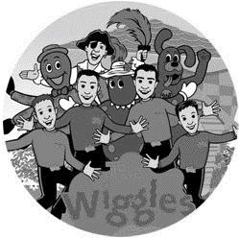

**Then, I learned…**

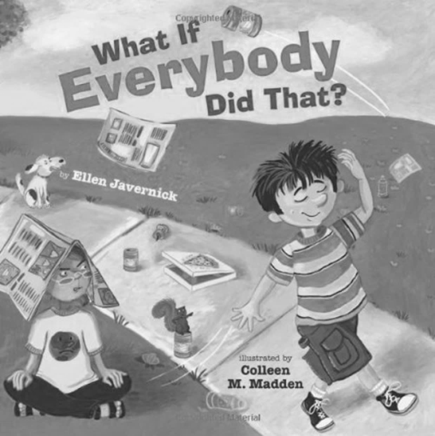

**Now, I think…**

☺ rules are important.

😐 that I am not sure if

rules are important.

☹ rules are not important.