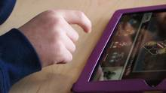
A third of students using classroom iPads for play, not work
MICHAEL OLIVEIRA
Excerpt from an article in The Canadian Press
Published Wednesday, Dec. 11, 2013 1:58PM EST

A third of 6,000 students surveyed about using iPads in class admitted to playing games during school hours. Surprisingly, 99 per cent said they found the gadgets distracting.

