11 Facts About Recycling
Retrieved 4-26-15 from https://www.dosomething.org/facts/11-facts-about-recycling
Welcome to DoSomething.org, one of the largest orgs for young people and social change! After you've browsed the 11 facts (with citations at the bottom), take action and volunteer with our millions of members. Sign up for a campaign and make the world suck less.
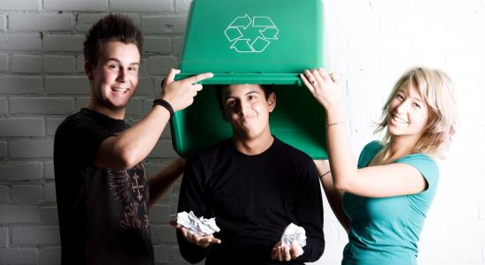
- The average person generates over 4 pounds of trash every day and about 1.5 tons of solid waste per year.
- Americans make more than 200 million tons of garbage each year, enough to fill Busch Stadium from top to bottom twice a day. Next time you’re at a sporting event or tailgate, host a trash-free tailgate using only recyclable materials Sign up for Trash-Free Tailgate.
- Over 75% of waste is recyclable, but we only recycle about 30% of it.
- We generate 21.5 million tons of food waste each year. If we composted that food, it would reduce the same amount of greenhouse gas as taking 2 million cars off the road.
- Recycling one aluminum can saves enough energy to listen to a full album on your iPod. Recycling 100 cans could light your bedroom for two whole weeks.
- Recycling aluminum cans saves 95% of the energy used to make alum cans from new material.
- Americans throw away 25,000,000 plastic bottles every hour.
- Over 87% of Americans have access to curbside or drop-off paper recycling programs.
- In 2009, Americans threw away almost 9 million tons of glass. That could fill enough tractor trailers to stretch from NYC to LA (and back!).
- In 2010, paper recycling had increased over 89% since 1990.
- If every American recycled just one-tenth of their newspapers, we could save about 25 million trees each year.

Sources
¹ Environmental Protection Agency. "Municipal Solid Waste." EPA. Accessed March 28, 2014. .
² Environmental Protection Agency. "10 FAST FACTS ON RECYCLING." EPA. http://www.epa.gov/reg3wcmd/solidwasterecyclingfacts.htm (accessed July 13, 2014).
³ Green Waste. "A Brighter Shade of Green." Recycling Stats. Accessed March 28, 2014. .
⁴ Green Waste. "A Brighter Shade of Green." Recycling Stats. Accessed March 28, 2014. .
⁵ SustainAbility. "Recycling Facts." Sustainability-Recycling. Accessed March 28, 2014. .
⁶ Earth911, Inc.. "Facts About Aluminum Recycling." Earth911.com. Accessed March 28, 2014. .
⁷ Green Waste. "A Brighter Shade of Green." Recycling Stats. Accessed March 28, 2014. .
⁸ Keep America Beautiful. "Recycling Facts & Statistics." Recycling in General. Accessed March 28, 2014. .
⁹ Keep America Beautiful. "Recycling Facts & Statistics." Recycling in General. Accessed March 28, 2014. .
¹⁰ Keep America Beautiful. "Recycling Facts & Statistics." Recycling in General. Accessed March 28, 2014. .
¹¹ SustainAbility. "Recycling Facts." Sustainability-Recycling. Accessed March 28, 2014. .

